Cloud Hosting vs. Self Hosting
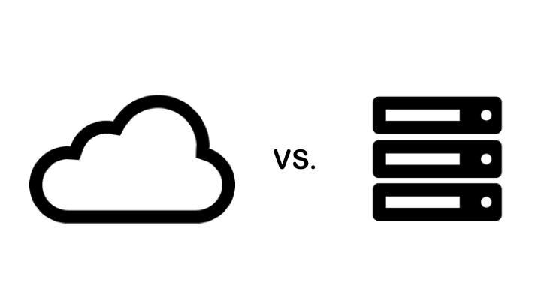
Cloud hosting is when an organization installs and accesses software on a server over the internet that is owned and managed by a third party organization. Self hosting is when an organization installs and accesses software from their own server. Self hosting is also often referred to as on premises or local hosting. When software applications are bundled with cloud hosting, this is referred to as Software as a Service (SaaS).

The OpenEMIS software is not platform dependent and can be either self hosted or cloud hosted on the OpenEMIS cloud servers. The OpenEMIS cloud servers are extremely reliable and highly secure as all data is encrypted. The OpenEMIS cloud servers are managed by highly technical support staff.

When deciding on cloud or self hosting, every organization is different and will have unique requirements. Choosing cloud or self hosting raises many questions; Do you have existing network and server infrastructure; or the capital to purchase new infrastructure; or the capital to upgrade and replace infrastructure? Do you have the technical knowledge or resources? Do you have a secure data center? Do you have a national data policy regarding the physical location of data?

There are advantages and disadvantages for both approaches:

 | Self-Hosted | Cloud Hosted
Infrastructure Costs | Larger capital costs for network and server infrastructure is required every 3 to 5 years | Smaller recurrent costs every month or year based on the IT resource utilization
Human Resource Costs | Need to employ or contract highly technical system administrators | Included in the cloud hosting cost
Facility Costs | Secure data center with high availability power, cooling, networking, rack space and 24 hour monitoring is recommended | Included in the cloud hosting cost
Speed | Infrastructure needs to be purchased, installed and configured which can take weeks or months | Servers can be quickly added, removed, upgraded or downgraded
Control | Complete control over infrastructure | Limited control over infrastructure
Disaster Recovery | Servers are installed in different data centers | Servers are configured in different locations
Scalable | New infrastructure needs to be purchased | Additional infrastructure can be enabled or disabled
Internet | Not required if there is an existing intranet. Using an existing intranet could be faster and cheaper. | Cloud hosting requires a good internet connection
Security | Physical security needs to be implemented and monitored | Included in the cloud hosting cost
Responsibility | Need to take full responsibility for any issues with the infrastructure | Cloud hosting provider takes responsibility for any issues with the infrastructure
Maintenance | Regular maintenance and software updates needs to be performed | Included in the cloud hosting cost

Based on many of the comparative advantages of cloud hosting mentioned above, many organizations and government agencies are migrating their Information systems to cloud hosting as it proves to be more cost-effective, flexible, secure and reliable in the long term. For example, banks use cloud hosting for some of their applications despite sensitiveness of their data. A report from the United Nations notes that “there are no general case for government policy and regulation to discourage migration towards the cloud. Rather than that, with careful assessment of the pros and cons of cloud solutions, governments are encouraged to build a framework for firms and organizations that wish to move to the new approach and recognize the diversity of business models and services available”.

References:

Amazon Web Services
https://aws.amazon.com/what-is-cloud-computing

Microsoft Azure
https://azure.microsoft.com/en-in/overview/what-is-cloud-computing

Wikipedia
https://en.wikipedia.org/wiki/Cloud_computing

Eurostat
http://ec.europa.eu/eurostat/statistics-explained/index.php/Cloud_computing_-_statistics_on_the_use_by_enterprises

United Nations Conference on Trade and Development
Information Economy Report 2013
The Cloud Economy and Developing Countries
ISSN 2075-4396
ISBN 978-92-1-112869-7
e-ISBN 978-92-1-054154-1
http://unctad.org/en/PublicationsLibrary/ier2013_en.pdf

