**OpenEMIS Concept Note – Disabilities in School**

*Tracking and Monitoring Disabilities in Schools*

*using an Open Education Management Information System (OpenEMIS)*

February, 2018

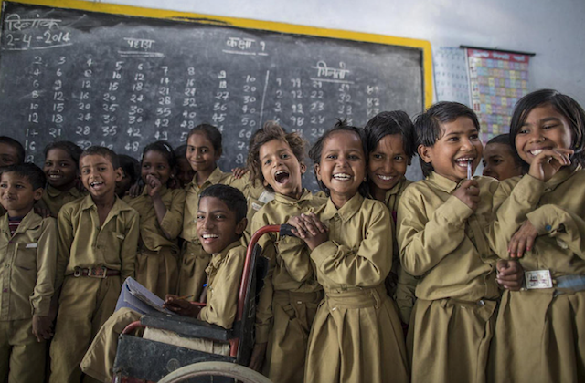

**Title**

Tracking and Monitoring Disabilities in School Data using an OpenEMIS

**OpenEMIS Initiative**

The OpenEMIS Initiative aims to deploy a high-quality Education Management Information System (EMIS) designed to collect and report data on schools, students, teachers, and staff. The system was conceived by UNESCO to be a royalty-free system that can be easily customized to meet the specific needs of member countries. The initiative is coordinated by UNESCO with technical support provided by Community Systems Foundation. OpenEMIS is well positioned to support national system strengthening in the country while addressing the monitoring requirements of Sustainable Development Goals. OpenEMIS is deployed as a cloud-based application and is designed to be mobile responsive, allowing for access to smartphones and tablets as well as more traditional laptop and desktop computers. A suite of tools is available to enhance OpenEMIS software, providing solutions for data collection, management, analysis and procurement of resources.

**Issue**

Children with disabilities face multiple forms of discrimination which leads to their exclusion from society and school. Facing daily discrimination in the form of negative attitudes, lack of adequate policies and legislation are effectively barred from realizing their rights to healthcare, education, and even survival. Attitudes toward children with disabilities, as well as a lack of resources to accommodate them, compound the challenges they face in accessing education. While lack of access to school is an issue, an equal concern is the inability of the education system to ensure quality education for children with disabilities. In order to have evidence to advocate for inclusion and create a baseline for monitoring progress in disability mainstreaming in the educational system, international communities are emphasizing the importance of collecting disaggregated data on the patterns of enrolment, attendance, completion, attainment and drop out as a result of having a disability.

**Approach/Solution**

OpenEMIS is an easily customizable and non-commercial software solution that member state countries can modify and update the requirements of education sector autonomously. OpenEMIS Core robust EMIS with data collected from institutions, staff, and students owned and managed by the Ministry of education. The application captures and tracks education data on student attendance, achievement, and behavior; tracks staff by location and level of qualifications; and tracks accommodation of special need students (e.g. vision, hearing, gross motor, fine motor, intellectual, communication, and behavior and socialization) following the national policies. Users are also able to set the tailored criteria so as to conduct a risk assessment by monitoring students in danger. OpenEMIS Integrator, OpenEMIS DataManager, and OpenEMIS Dashboard allow facilitating information flow between the software and other relevant management tools used for the education policy planning. The applications visualize trends with disabilities indicators as well as link education to the other sectors that policymakers can monitor comprehensive information in a timely manner.

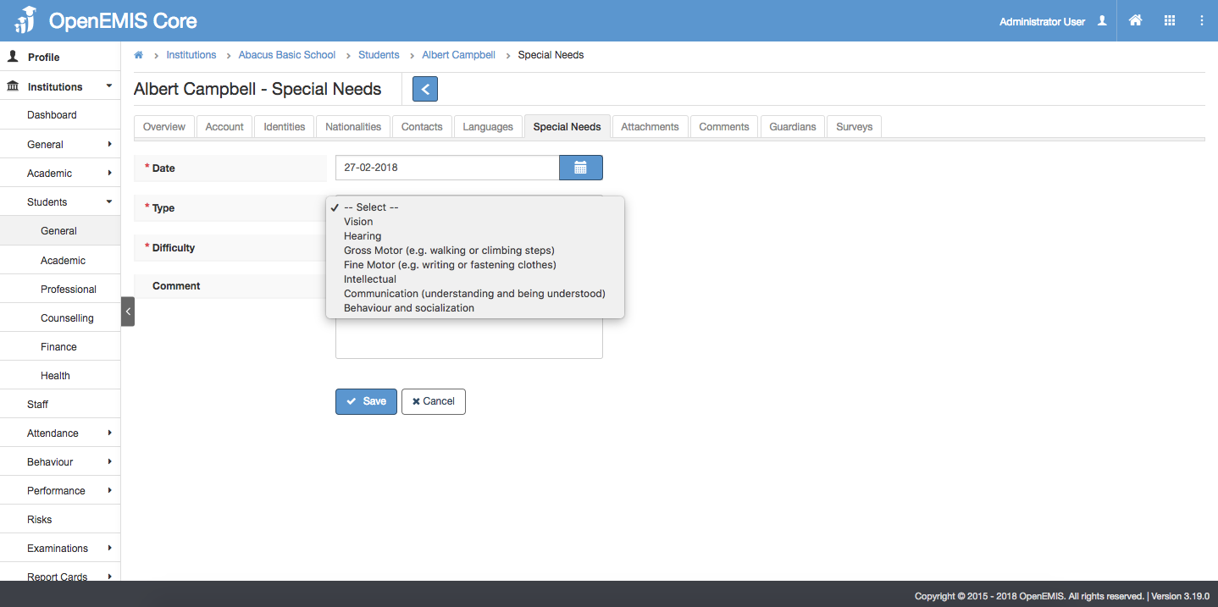

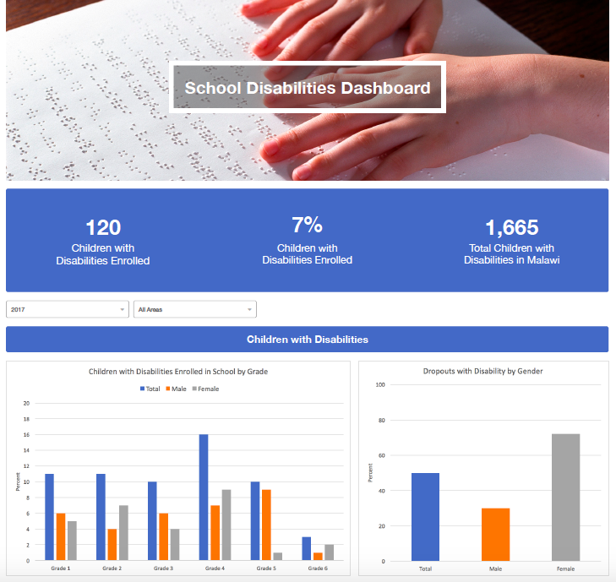

**Measurement**

Following list of indicators and more can be monitored through OpenEMIS:

* Children with disabilities enrolled in school
* Dropouts with disability
* Students with disability and support needs (e.g. vision, hearing, gross motor, fine motor, intellectual, communication, and behavioral and social impairment)
* Accessibility of physical structures and materials (e.g. physical structure, institution facilities, toilets by designation, student toilets by types, general materials, special materials, and quality of special materials)
* Teachers trained on teaching children with disabilities
* Children with disabilities receiving special services

**Support**

To ensure quality project activities for long-term sustainable development, OpenEMIS is providing six types of services (i.e. Policy and Planning Services; Analytical Services; Implementation Services; Support Services; Ad Hoc Services; and Software Development Services) along with Training Services (i.e. Professional; Administrator; Analyst; Trainer; and Advanced Lab) for countries’ capacity building. Moreover, OpenEMIS runs Service Desk from education experts and technicians to support users’ questions and requests as well as online OpenEMIS Support[1] where clients get access to the knowledge base on all applications.

**References**

United Nations Children’s Fund (UNICEF). Disabilities in Education. <https://www.unicef.org/disabilities/index_65316.html>

United Nations Children’s Fund (UNICEF). Disabilities Introduction. <https://www.unicef.org/disabilities/>

United Nations Educational, Scientific and Cultural Organization (UNESCO). Education Indicators Technical Guidelines 2009 (English, PDF).

<https://www.openemis.org/files/resources/Indicator_Technical_guidelines_en.pdf>

1. https://www.openemis.org/support/