OpenEMIS Concept Note – ECDE
Tracking and Monitoring Early Childhood Development and Education Data using an Open Education Management Information System (OpenEMIS)

January, 2018

Title
Tracking and Monitoring Early Childhood Development and Education (ECDE) Data using an OpenEMIS

OpenEMIS Initiative
The OpenEMIS Initiative aims to deploy a high-quality Education Management Information System (EMIS) designed to collect and report data on schools, students, teachers, and staff. The system was conceived by UNESCO to be a royalty-free system that can be easily customized to meet the specific needs of member countries. The initiative is coordinated by UNESCO with technical support provided by Community Systems Foundation. OpenEMIS is well positioned to support national system strengthening in the country while addressing the monitoring requirements of Sustainable Development Goals. OpenEMIS is deployed as a cloud-based application and is designed to be mobile responsive, allowing for access to smartphones and tablets as well as more traditional laptop and desktop computers. A suite of tools is available to enhance OpenEMIS software, providing solutions for data collection, management, analysis and procurement of resources.

Issue
Early childhood, defined as the period from birth to eight years old is a time of remarkable growth in holistic development of a child’s social, emotional, cognitive and physical needs in order to build a solid and broad foundation for lifelong learning and wellbeing. The new Sustainable Development Goal 4 which aims to “By 2030, ensure that all girls and boys have access to quality early childhood development, care and pre-primary education so that they are ready for primary education” along with associated stakeholders encourage member states to focus on influencing policies and practices through evidence-based advocacy by collecting systematic ECDE data and monitor the development status and performance of national ECDE systems. The lack of concrete monitoring system with the use of developmentally on track data and the linkages among primary education, early childhood health, nutrition and social services challenges the status of tracking ECDE systems.

Approach/Solution
OpenEMIS is an easily customizable and non-commercial software solution that member state countries can modify and update the requirements of ECDE sector autonomously. The OpenEMIS Core robust ECDE-Monitoring Information System (MIS) with data collected from institutions, staff, and students owned and managed by the Ministry and ECDE authorities. The application captures and tracks ECDE data on student attendance, achievement, and behavior; tracks staff by location and level of qualifications; and tracks accommodation of special need students following the national policies. The OpenEMIS Integrator, OpenEMIS DataManager, and OpenEMIS Dashboard allow facilitating information flow between the software and other relevant management tools used for the health, nutrition and social information in an ECDE context. The applications visualize trends with key ECDE indicators as well as link ECDE policy to the primary education to ensure that ECDE initiatives align with other education levels simultaneously and equally.

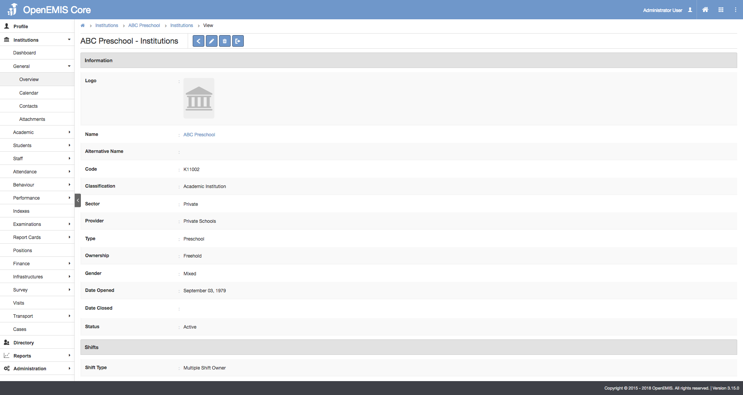

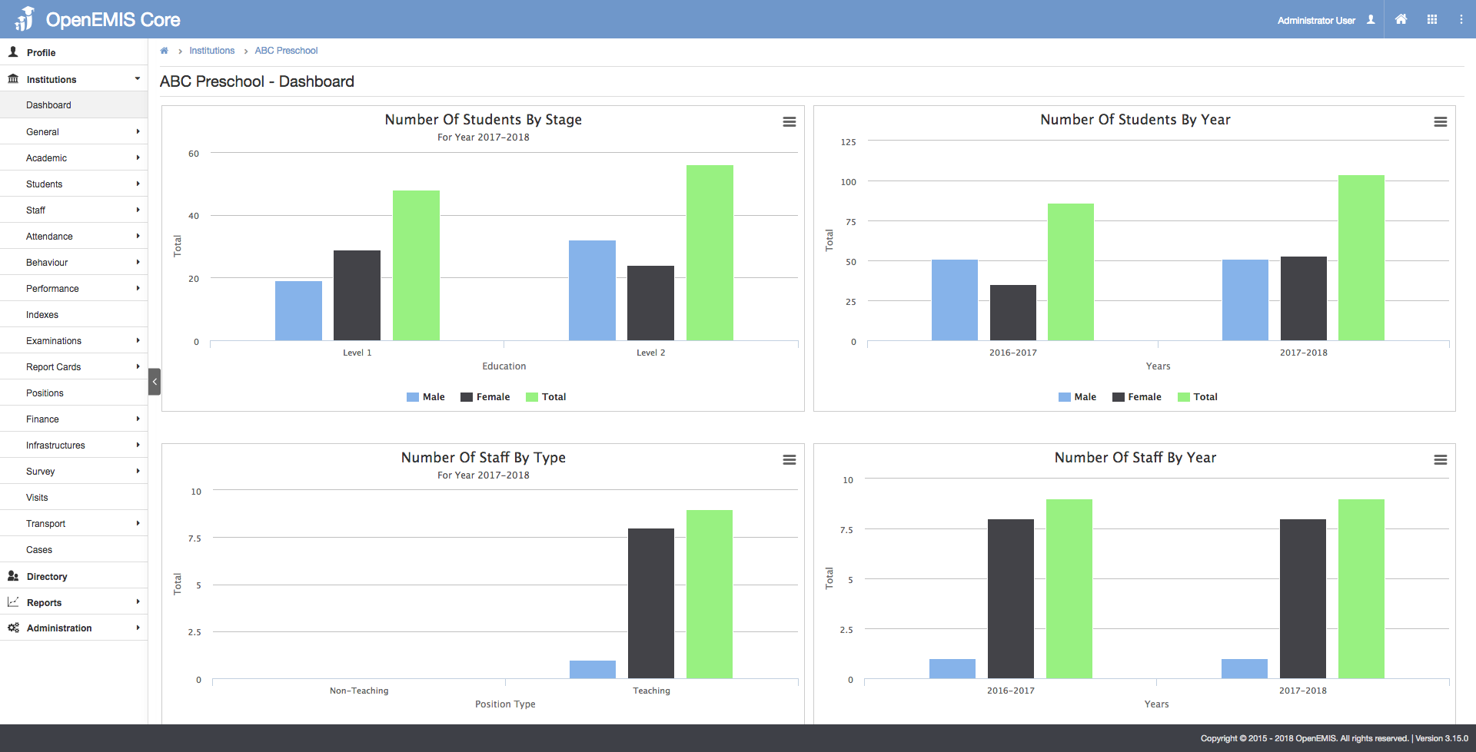

Measurement
Following list of indicators and more can be monitored through OpenEMIS:
- Number of students in pre-primary institutions
- Percentage of students identified as vulnerable (e.g. disability)
- Number of staff in pre-primary institutions
- Number of qualified teaching staff in pre-primary institutions
- Number of pre-primary institutions
- Gross enrolment ratio in pre-primary
- Participation rate in organized learning
- Percentage of children, aged 6-7 years, entering school, having attended any form of preschool education (at least 1 school year)

Support
To ensure quality project activities for long-term sustainable development, OpenEMIS is providing six types of services (i.e. Policy and Planning Services; Analytical Services; Implementation Services; Support Services; Ad Hoc Services; and Software Development Services) along with Training Services (i.e. Professional; Administrator; Analyst; Trainer; and Advanced Lab) for countries’ capacity building. Moreover, OpenEMIS runs Service Desk from education experts and technicians to support users’ questions and requests as well as online OpenEMIS Support where clients get access to the knowledge base on all applications.

References
United Nations Educational, Scientific and Cultural Organization (UNESCO). Early Childhood Care and Education. https://en.unesco.org/themes/early-childhood-care-and-education

United Nations Children’s Fund (UNICEF). Early Childhood Development. https://www.unicef.org/earlychildhood/

United Nations Educational, Scientific and Cultural Organization (UNESCO). Education Indicators Technical Guidelines 2009 (English, PDF).
https://www.openemis.org/files/resources/Indicator_Technical_guidelines_en.pdf

https://www.openemis.org/support/

