OpenEMIS Concept Note – Education in Emergencies
Tracking and Monitoring Education in Emergencies Data
using an Open Education Management Information System (OpenEMIS)

March, 2018

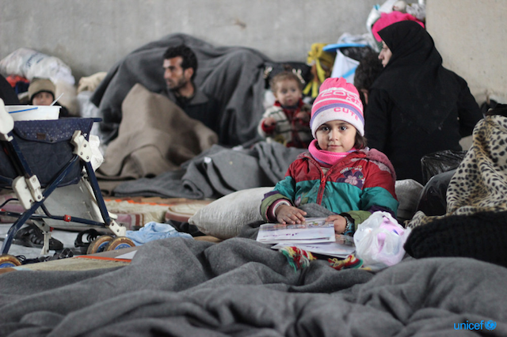
Photo copyright from UNICEF

Title
Tracking and Monitoring Education in Emergencies Data using an OpenEMIS

OpenEMIS Initiative
The OpenEMIS Initiative aims to deploy a high-quality Education Management Information System (EMIS) designed to collect and report data on schools, students, teachers, and staff. The system was conceived by UNESCO to be a royalty-free system that can be easily customized to meet the specific needs of member countries. The initiative is coordinated by UNESCO with technical support provided by Community Systems Foundation. OpenEMIS is well positioned to support national system strengthening in the country while addressing the monitoring requirements of Sustainable Development Goals. OpenEMIS is deployed as a cloud-based application and is designed to be mobile responsive, allowing for access to smartphones and tablets as well as more traditional laptop and desktop computers. A suite of tools is available to enhance OpenEMIS software, providing solutions for data collection, management, analysis and procurement of resources.

Issue
According to the findings from the international community, 35% of out-of-school children of primary school age worldwide live in 32 countries affected by conflict, while only 1.4% of humanitarian aid was invested in education in 2016. In that regard, the Sustainable Development Goal 4, “ensuring inclusive and equitable quality education and promote lifelong learning opportunities for all” requires a much greater commitment in education for resolving conflict and crisis contexts. Studies from Cambridge Education reveals that a serious lack of reliable data on monitoring Education in Emergencies fails to track children’s access and attainment of education pathways. International organizations emphasize the importance of developing and/or rehabilitating a comprehensive national EMIS that ensures collecting and reporting disaggregated data associated with student attendance, performance, behavior to address the issues and gaps in observing children in danger.

Approach/Solution
OpenEMIS is an easily customizable and non-commercial software solution that member state countries can modify and update the requirements of education sector autonomously. Since 2014, Jordan has been using OpenEMIS Core in nationwide to collect school as well as central level information. The system was additionally customized into OpenEMIS Refugees to track data of Syrian refugee children by capturing student data on attendance, achievement, and behavior; tracking staff data by location and level of qualifications; and tracking accommodation of special need students following the national policies. Special dashboard using OpenEMIS Dashboard to visualize trends of key performance indicators and monitor inter-sectoral data was created for policy planners to track refugee status in a timely manner. The Out of School Children feature in OpenEMIS Core enables identifying children at risk of dropout by creating a set of criteria (e.g. absences late; absences unexcused; guardians; and special needs) that comprises of measuring dropout indexes. The system also allows extracting student reports in a Microsoft Excel format to manage students in danger holistically.

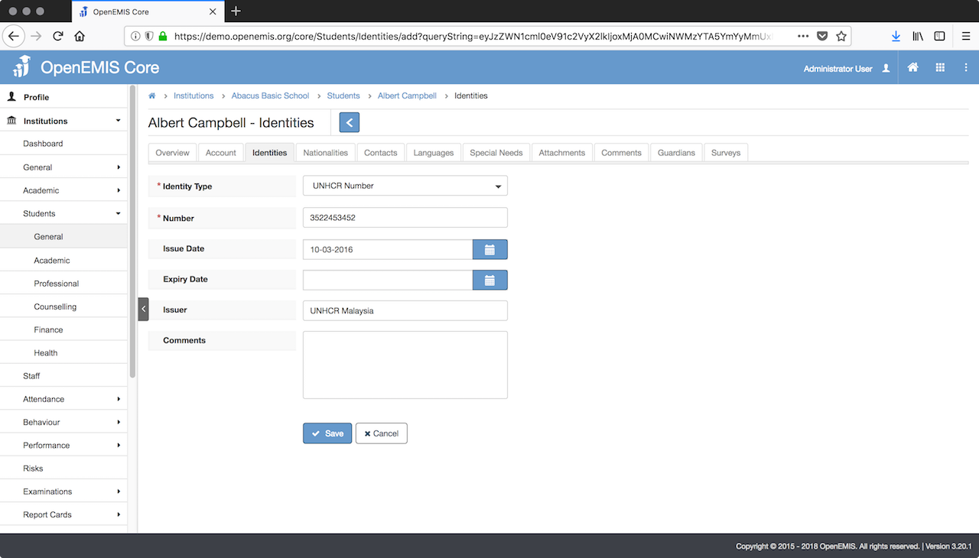

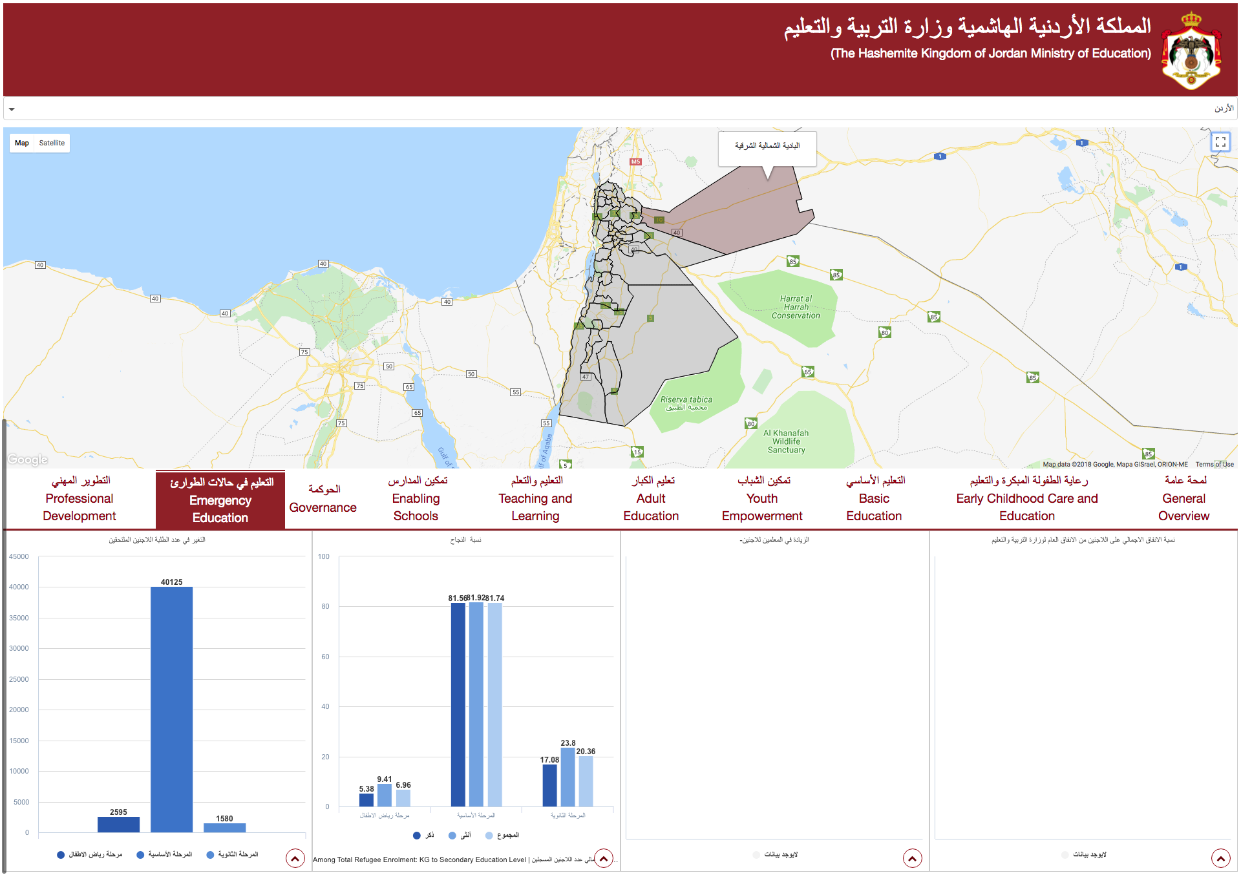

Measurement
Following list of indicators and more can be monitored through OpenEMIS:
- Number of students / staff / institutions
- Percentage of students identified as vulnerable (e.g. disability)
- Number of qualified teaching staff in institutions
- Number of students identified as risk of dropout
- Gross enrolment ratio
- Net enrolment rate
- Adjusted net enrolment rate
- Number of out-of-school children of primary / secondary age
- Out-of-school rate for children of primary / secondary age
- Survival rate to the last grade of primary / secondary education
- Percentage of children in primary / secondary education who drop out before the last grade
- Percentage of new entrants to primary education without early childhood education

Support
To ensure quality project activities for long-term sustainable development, OpenEMIS is providing six types of services (i.e. Policy and Planning Services; Analytical Services; Implementation Services; Support Services; Ad Hoc Services; and Software Development Services) along with Training Services (i.e. Professional; Administrator; Analyst; Trainer; and Advanced Lab) for countries’ capacity building. Moreover, OpenEMIS runs Service Desk from education experts and technicians to support users’ questions and requests as well as online OpenEMIS Support where clients get access to the knowledge base on all applications.

References
Cambridge Education. Evidence Brief 6: Data, Monitoring and Evaluation. November 2017.
https://www.dai.com/uploads/Theme%206%20-%20Data%20monitoring%20and%20evaluation%2008.01.18.pdf

Inter-Agency Network for Education in Emergencies (INEE). Minimum Standards for Education in Emergencies, Chronic Crises and Early Reconstruction. 2004.
https://www.unicef.org/violencestudy/pdf/min_standards_education_emergencies.pdf

United Nations Educational, Scientific and Cultural Organization (UNESCO). Education Indicators Technical Guidelines 2009 (English, PDF).
https://www.openemis.org/files/resources/Indicator_Technical_guidelines_en.pdf

United Nations Educational, Scientific and Cultural Organization Institute for Statistics (UIS). Leaving no one behind: How far on the way to universal primary and secondary education?. Policy Paper 27/Fact Sheet 37. July 2017.
https://www.compassion.com/multimedia/global-education-monitoring-report.pdf

United Nations Office for the Coordination of Humanitarian Affairs (UNOCHA). Financial Tracking Service. https://fts.unocha.org/

https://www.openemis.org/support/

