OpenEMIS Concept Note – School Meals
Tracking and Monitoring School Meals Data using an Open Education Management Information System (OpenEMIS)

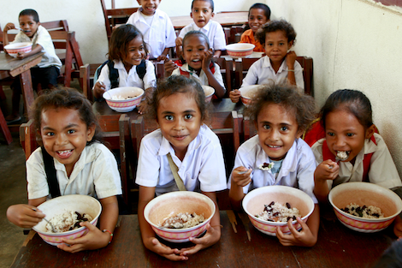
Title
Tracking and Monitoring School Meals Data using an OpenEMIS

OpenEMIS Initiative
The OpenEMIS Initiative aims to deploy a high-quality Education Management Information System (EMIS) designed to collect and report data on schools, students, teachers, and staff. The system was conceived by UNESCO to be a royalty-free system that can be easily customized to meet the specific needs of member countries. The initiative is coordinated by UNESCO with technical support provided by Community Systems Foundation. OpenEMIS is well positioned to support national system strengthening in the country while addressing the monitoring requirements of Sustainable Development Goals. OpenEMIS is deployed as a cloud based application and is designed to be mobile responsive, allowing for access on smartphones and tablets as well as more traditional laptop and desktop computers. A suite of tools is available to enhance OpenEMIS software, providing solutions for data collection, management, analysis and procurement of resources.

Issue
According to the World Food Programme (WFP), countless children across the globe turn up for school on an empty stomach every day, which makes it hard to focus on lessons. Many simply do not go, as their families need them to help in the fields or around the house. For all of them, a daily school meal can mean not only better nutrition and health, but also increased access to and achievement in education. It is also a strong incentive to consistently send children to school. The benefits and impacts of school meals align well with the Sustainable Development Goals (SDGs). Many countries are already providing school meals; however, it is not clear what impact these meals are having in terms of student attendance and achievement.

Approach/Solution
The OpenEMIS Core Meal feature collects data on meal programmes, benefit types, and the students participating in meal programmes. Information such as the target group, delivery frequency, nutritional content and implementer are captured for the different meal programmes. Additional custom fields can also be added based on specific country contexts. The Meal feature tracks the benefit type and coverage per students (i.e. some students may need to pay while other students may receive meals for free) as well. Each meal programme and students’ participation in that programme is tracked by academic period so that the data can be trended over time. At the school level, the OpenEMIS Core Meal feature can track the number of meals received, the delivery status (i.e. on time, late or not delivered) and the number of meals distributed by student. Finally, the feature tracks how much money was paid per student for those receiving less than 100% benefit type.
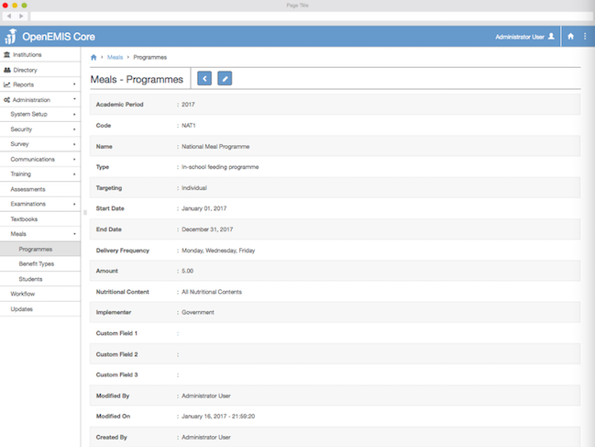

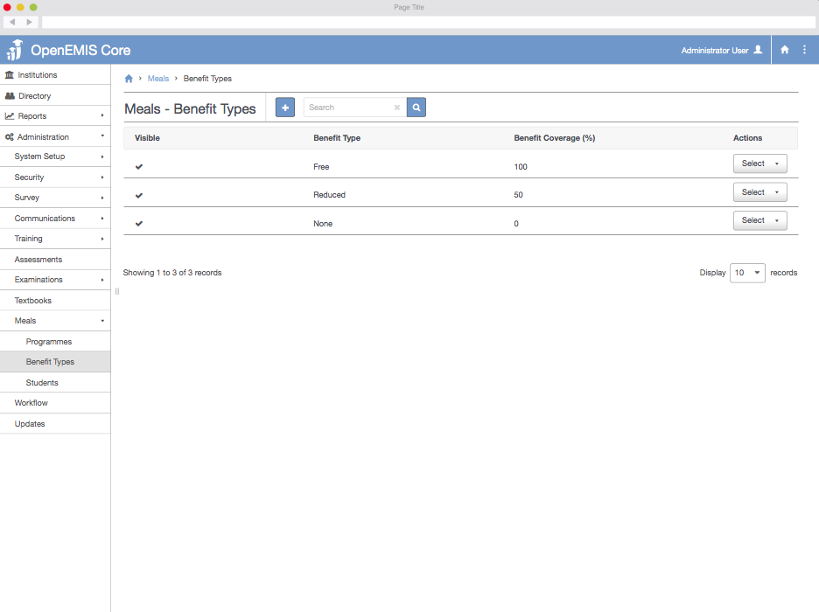

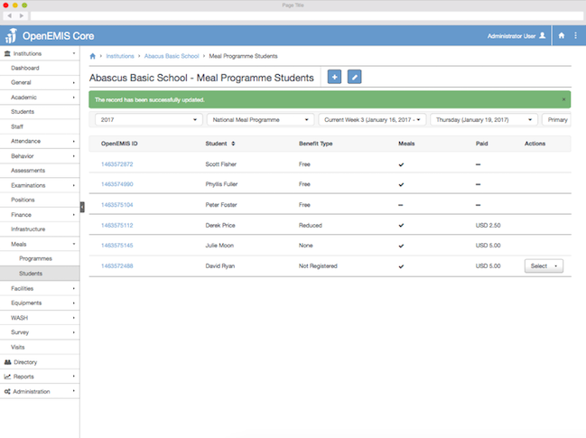

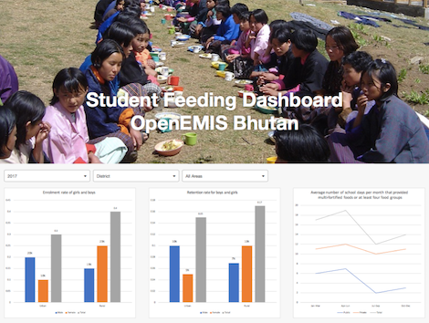
Measurement
Following list of indicators and more can be monitored through OpenEMIS:
- Number of beneficiaries receiving assistance as percentage of planned
- Number of national programmes developed with WFP support (nutrition, school feeding, safety net)
- Quantity of food assistance distributed as percentage of planned distribution
- Quantity of food procured by public institutions receiving WFP support
- Total value of vouchers distributed (expressed in food/cash)
- Average number of school days per month that provided multi-fortified foods or at least four food groups
- Enrolment rate for boys and girls
- Retention rate for boys and girls

Support
To ensure quality project activities for long term sustainable development, OpenEMIS is providing six types of services (i.e. Policy and Planning Services; Analytical Services; Implementation Services; Support Services; Ad Hoc Services; and Software Development Services) along with Training Services (i.e. Professional; Administrator; Analyst; Trainer; and Advanced Lab) for countries’ capacity building. Moreover, OpenEMIS runs Service Desk from education experts and technicians to support users’ questions and requests as well as online OpenEMIS Support where clients get access to knowledge base on all applications.

References
World Food Programme (WFP). School Meals. www1.wfp.org/school-meals

World Food Programme (WFP). Revised School Feeding Policy 2013 (Engligh, PDF). https://www.openemis.org/files/resources/WFP_Revised_School_Feeding_Policy_2013_en.pdf

United Nations Educational, Scientific and Cultural Organization (UNESCO). Education Indicators Technical Guidelines 2009 (English, PDF).
https://www.openemis.org/files/resources/Indicator_Technical_guidelines_en.pdf

https://www.openemis.org/support/

