OpenEMIS Concept Note – OOSC
Tracking and Monitoring Out of School Children Data
using an Open Education Management Information System (OpenEMIS)

February, 2018

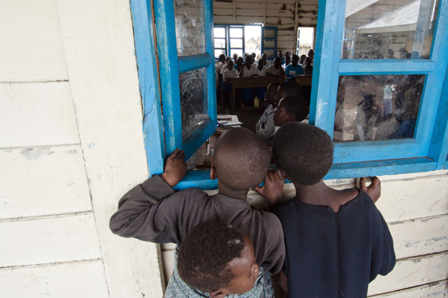

Title
Tracking and Monitoring Out of School Children (OOSC) Data using an OpenEMIS

OpenEMIS Initiative
The OpenEMIS Initiative aims to deploy a high-quality Education Management Information System (EMIS) designed to collect and report data on schools, students, teachers, and staff. The system was conceived by UNESCO to be a royalty-free system that can be easily customized to meet the specific needs of member countries. The initiative is coordinated by UNESCO with technical support provided by Community Systems Foundation. OpenEMIS is well positioned to support national system strengthening in the country while addressing the monitoring requirements of Sustainable Development Goals. OpenEMIS is deployed as a cloud-based application and is designed to be mobile responsive, allowing for access to smartphones and tablets as well as more traditional laptop and desktop computers. A suite of tools is available to enhance OpenEMIS software, providing solutions for data collection, management, analysis and procurement of resources.

Issue
Despite dramatic improvements over the past years, progress towards achieving Education For All (EFA) has stagnated. In total, 264 million children, adolescents, and youth were out of school for the school year ending in 2015 according to UNESCO Institute for Statistics (UIS). This is equivalent to a quarter of the population of Europe. The progress has not been equitable; the children who face the most severe barriers to education, such as those associated with gender, poverty, displacement, nomadism, disability, and/or ethnicity, are still left behind. Of all the regions, sub-Saharan Africa has the highest rates of exclusion. Likewise, in every region, older youth, as well as poorest children, face greater barriers to education. Girls are more likely than boys never to set foot in a classroom, despite all the efforts and progress made over the past two decades. Armed conflict poses another major barrier to education. In that regard, it is crucial to have a systematic OOSC data monitoring mechanism to measure accurate OOSC indicators and address the issue effectively.

Approach/Solution
OpenEMIS is an easily customizable and non-commercial software solution that member state countries can modify and update the requirements of education sector autonomously. OpenEMIS Core, which captures and tracks educational data on students, staff, and institutions provides features that enable to monitor OOSC data. In order to identify children at risk of dropout, users can create several criteria (e.g. absences late; absences unexcused; guardians; and special needs) that comprises of measuring dropout indexes. Also, users are able to extract OOSC student reports in a Microsoft Excel format so as to manage students in danger holistically. OpenEMIS Integrator, OpenEMIS DataManager, and OpenEMIS Dashboard allow facilitating information flow between the software and other relevant management tools used for OOSC monitoring by visualizing trends with OOSC indicators.

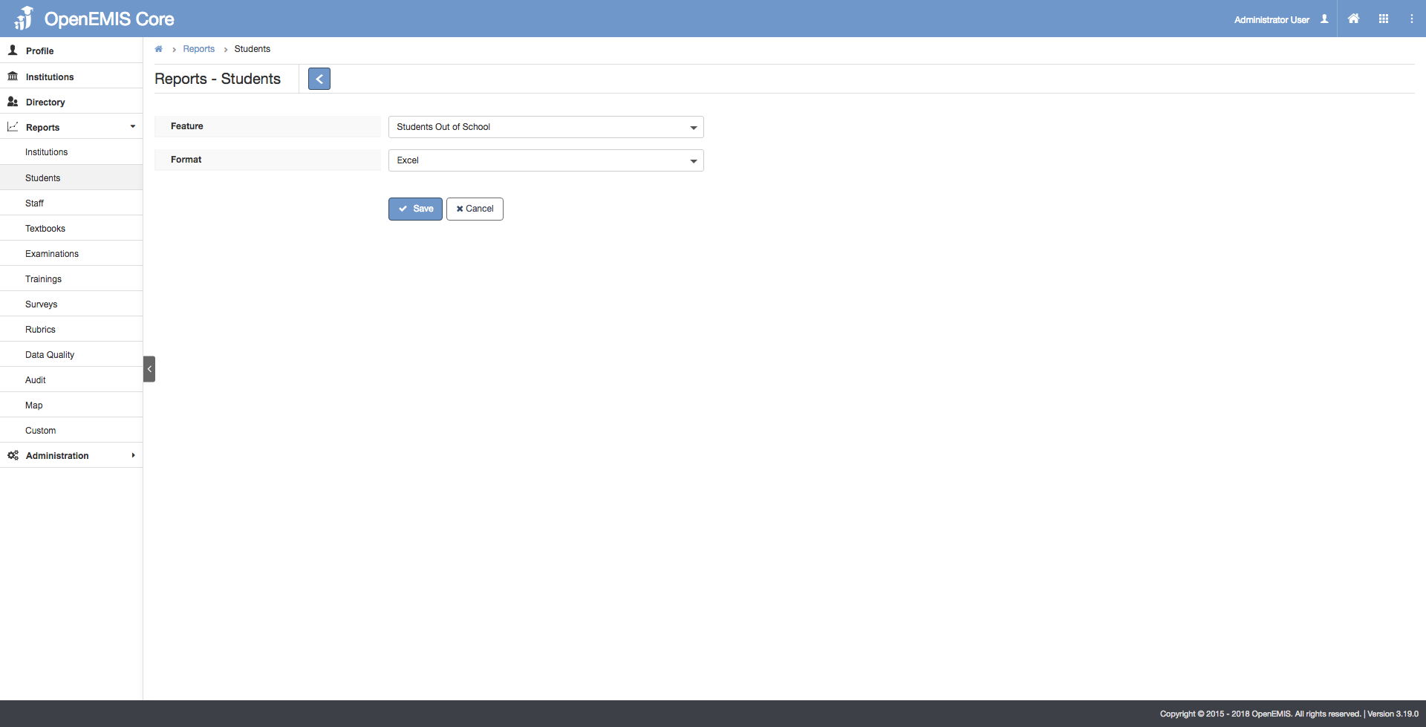

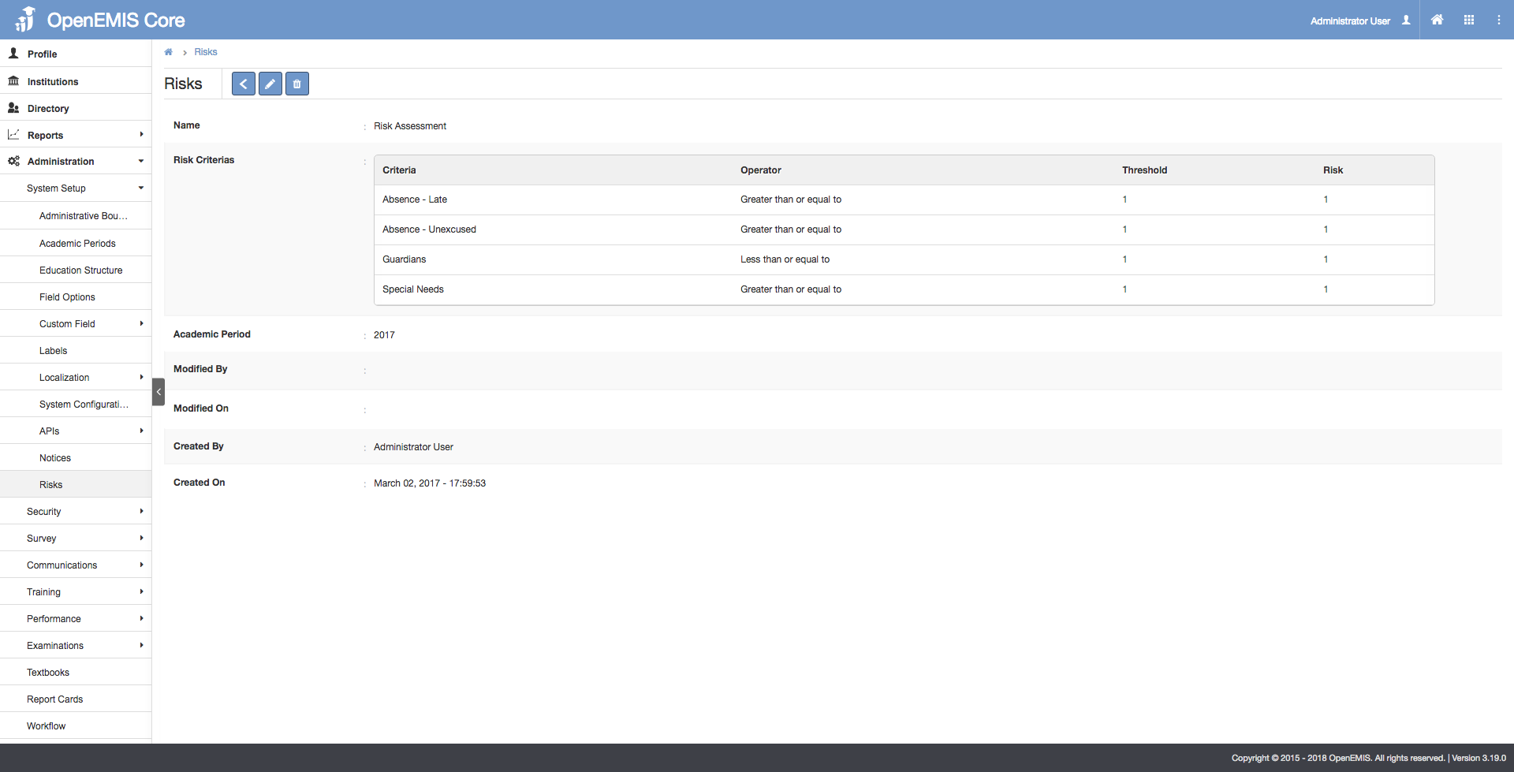

Measurement
Following list of indicators and more can be monitored through OpenEMIS:
- Number of students / staff / institutions
- Number of out-of-school children of pre-primary / primary / secondary age
- Out-of-school rate for children of pre-primary / primary / secondary age
- Net enrolment rate in pre-primary / primary / secondary education
- Adjusted net enrolment rate in pre-primary / primary / secondary education
- Survival rate to the last grade of pre-primary / primary / secondary education
- Percentage of children in pre-primary / primary / secondary education who drop out before the last grade
- Percentage of new entrants to primary education without early childhood education

Support
To ensure quality project activities for long-term sustainable development, OpenEMIS is providing six types of services (i.e. Policy and Planning Services; Analytical Services; Implementation Services; Support Services; Ad Hoc Services; and Software Development Services) along with Training Services (i.e. Professional; Administrator; Analyst; Trainer; and Advanced Lab) for countries’ capacity building. Moreover, OpenEMIS runs Service Desk from education experts and technicians to support users’ questions and requests as well as online OpenEMIS Support where clients get access to the knowledge base on all applications.

References
Global Partnership for Education (GPE). Out-of-school Children.
https://www.globalpartnership.org/focus-areas/out-of-school-children

United Nations Educational, Scientific and Cultural Organization (UNESCO). Education Indicators Technical Guidelines 2009 (English, PDF).
https://www.openemis.org/files/resources/Indicator_Technical_guidelines_en.pdf

United Nations Educational, Scientific and Cultural Organization Institute for Statistics (UIS). 263 Million Children and Youth are Out of School.
http://uis.unesco.org/en/news/263-million-children-and-youth-are-out-school

United Nations Educational, Scientific and Cultural Organization Institute for Statistics (UIS) & United Nations Children’s Fund (UNICEF). Global Out-of-School Children Initiative – Operational Manual.
http://unesdoc.unesco.org/images/0024/002475/247531e.pdf

https://www.openemis.org/support/

