OpenEMIS Concept Note – TVET
Tracking and Monitoring Technical and Vocational Education and Training Data using an Open Education Management Information System (OpenEMIS)

January, 2018

Title
Tracking and Monitoring Technical and Vocational Education and Training (TVET) Data using an OpenEMIS

OpenEMIS Initiative
The OpenEMIS Initiative aims to deploy a high-quality Education Management Information System (EMIS) designed to collect and report data on schools, students, teachers, and staff. The system was conceived by UNESCO to be a royalty-free system that can be easily customized to meet the specific needs of member countries. The initiative is coordinated by UNESCO with technical support provided by Community Systems Foundation. OpenEMIS is well positioned to support national system strengthening in the country while addressing the monitoring requirements of Sustainable Development Goals. OpenEMIS is deployed as a cloud-based application and is designed to be mobile responsive, allowing for access to smartphones and tablets as well as more traditional laptop and desktop computers. A suite of tools is available to enhance OpenEMIS software, providing solutions for data collection, management, analysis and procurement of resources.

Issue
Technical and Vocational Education and Training (TVET) is concerned with the acquisition of knowledge and skills for the world of work, and is expected to help youth and adults develop the skills they need for employment, decent work and entrepreneurship, promoting equitable, inclusive and sustainable economic growth, and supporting transitions to green economies and environmental sustainability. According to United Nations Educational, Scientific, and Cultural Organization (UNESCO), member states are recommended to underscore the need to develop TVET Management Information System (TVET-MIS), statistics and indicators as well as cross-national statistical frameworks and data platforms for monitoring national skills. The lack of systematic collection and aggregation of data presents severe challenges for monitoring the development status and performance of national TVET systems.

Approach/Solution
OpenEMIS is an easily customizable and non-commercial software solution that member state countries can modify and update the requirements of TVET sector autonomously. The OpenEMIS Core robust TVET-MIS with data collected from institutions, staff, and students owned and managed by the Ministry and TVET authorities. The application captures and tracks TVET data on student attendance, achievement, and behavior; tracks staff by location and level of qualifications; and tracks accommodation of special need students following the national policies. The OpenEMIS Integrator, OpenEMIS DataManager, and OpenEMIS Dashboard allow facilitating information flow between the software and other relevant management tools used for the labour market and training information in a TVET context. The applications visualize trends with key TVET indicators as well as link TVET policy to the labour market to ensure that TVET initiatives are meeting the market demand in a timely manner.

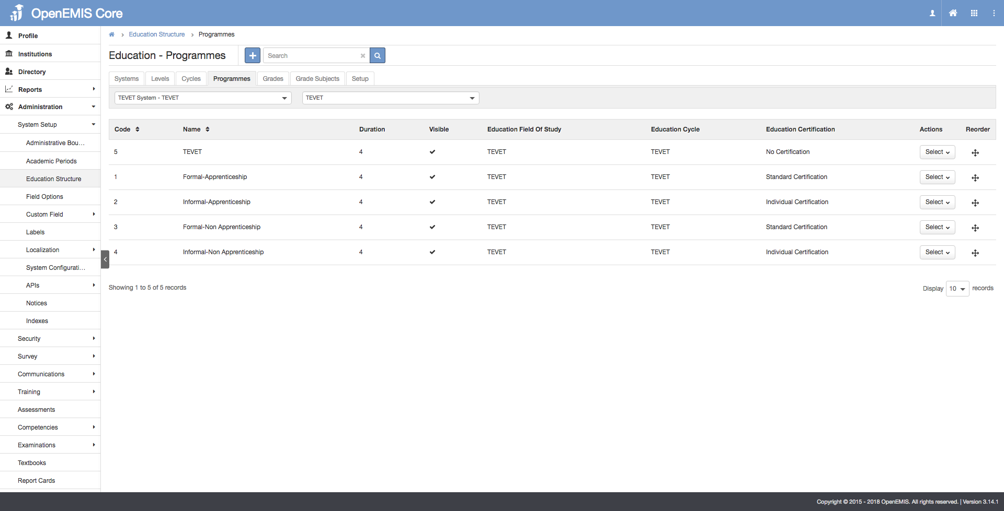

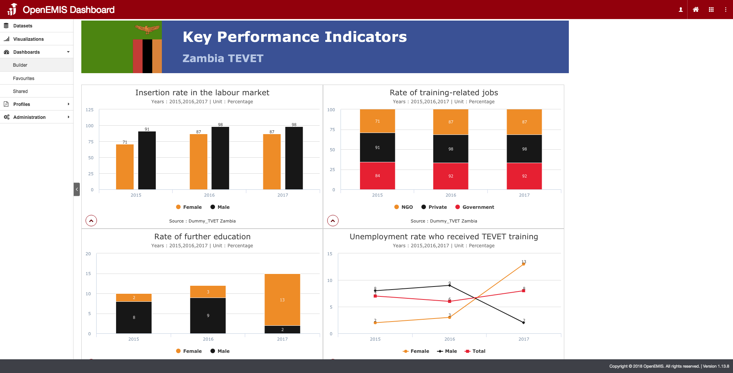

Measurement
Following list of indicators and more can be monitored through OpenEMIS:
- Number of students in TVET institutions
- Percentage of students identified as vulnerable (e.g. disability)
- Number of staff in TVET institutions
- Number of qualified teaching staff in TVET institutions
- Number of TVET institutions
- Number of TVET programs offered
- Diversity of financial contributions needed for the replacement and equipment maintenance
- Average rate of pay

Support
To ensure quality project activities for long-term sustainable development, OpenEMIS is providing six types of services (i.e. Policy and Planning Services; Analytical Services; Implementation Services; Support Services; Ad Hoc Services; and Software Development Services) along with Training Services (i.e. Professional; Administrator; Analyst; Trainer; and Advanced Lab) for countries’ capacity building. Moreover, OpenEMIS runs Service Desk from education experts and technicians to support users’ questions and requests as well as online OpenEMIS Support where clients get access to the knowledge base on all applications.

References
United Nations Educational, Scientific and Cultural Organization (UNESCO) – UNEVOC. TVET Strategy. http://www.unevoc.unesco.org/go.php?q=UNESCO+TVET+Strategy+2016-2021

United Nations Educational, Scientific and Cultural Organization (UNESCO). Education Indicators Technical Guidelines 2009 (English, PDF).
https://www.openemis.org/files/resources/Indicator_Technical_guidelines_en.pdf

https://www.openemis.org/support/

