OpenEMIS Concept Note – WASH in Schools
Tracking and Monitoring Water, Sanitation, and Hygiene (WASH) in Schools Data using an Open Education Management Information System (OpenEMIS)

February, 2018

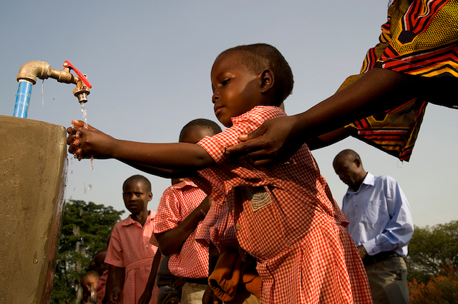

Title
Tracking and Monitoring Water, Sanitation, and Hygiene (WASH) in Schools Data using an OpenEMIS

OpenEMIS Initiative
The OpenEMIS Initiative aims to deploy a high-quality Education Management Information System (EMIS) designed to collect and report data on schools, students, teachers, and staff. The system was conceived by UNESCO to be a royalty-free system that can be easily customized to meet the specific needs of member countries. The initiative is coordinated by UNESCO with technical support provided by Community Systems Foundation. OpenEMIS is well positioned to support national system strengthening in the country while addressing the monitoring requirements of Sustainable Development Goals. OpenEMIS is deployed as a cloud-based application and is designed to be mobile responsive, allowing for access to smartphones and tablets as well as more traditional laptop and desktop computers. A suite of tools is available to enhance OpenEMIS software, providing solutions for data collection, management, analysis and procurement of resources.

Issue
Water, Sanitation, and Hygiene in schools not only promotes hygiene and increases access to quality education but also supports national and local interventions to establish equitable, sustainable access to safe water and basic sanitation services in schools. Poor sanitation, water scarcity, inferior water quality and inappropriate hygiene behavior are disastrous for infants and young children and are a major cause of mortality for children under five. Monitoring can help decision-makers and planners in government, donor organizations and civil society to decide how best to focus investments, technical assistance, and other interventions within WASH in schools. International organizations recommend the availability and functionality of WASH facilities and hygienic practices among school children should be part of an EMIS rather than a component of the monitoring and evaluation system. Including WASH in schools in the EMIS gives a clearer insight into the existing educational problems and challenges such as the possible link between WASH and school attendance and retention.

Approach/Solution
OpenEMIS is an easily customizable and non-commercial software solution that member state countries can modify and update the requirements of education sector autonomously. OpenEMIS Core robust EMIS with data collected from institutions, staff, and students owned and managed by the Ministry of Education. The application captures and tracks Water (e.g. type, functionality, proximity, quantity, quality, and accessibility), Sanitation (e.g. type, use, gender, quality, and accessibility), Hygiene (e.g. type, soap/ash availability, hygiene education, and accessibility), Waste (e.g. type and functionality), and Sewage (e.g. type and functionality) data following the national standards. These fields of criteria can be adjustable depending on user’s demand. OpenEMIS Integrator, OpenEMIS DataManager, and OpenEMIS Dashboard allow facilitating information flow between the software and other relevant management tools used for the education policy planning. The applications visualize trends with WASH indicators as well as link education to the other sectors that policymakers can monitor comprehensive information in a timely manner.

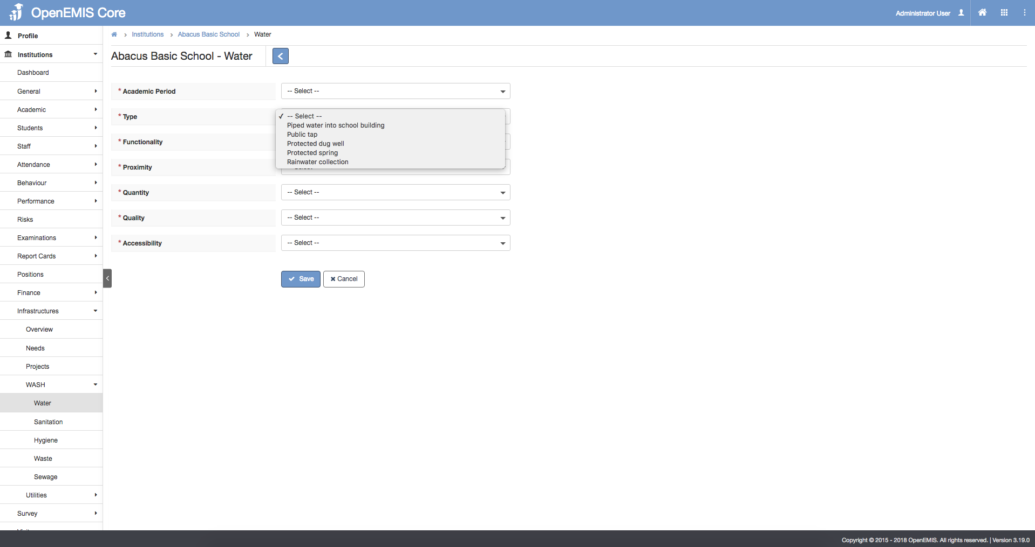

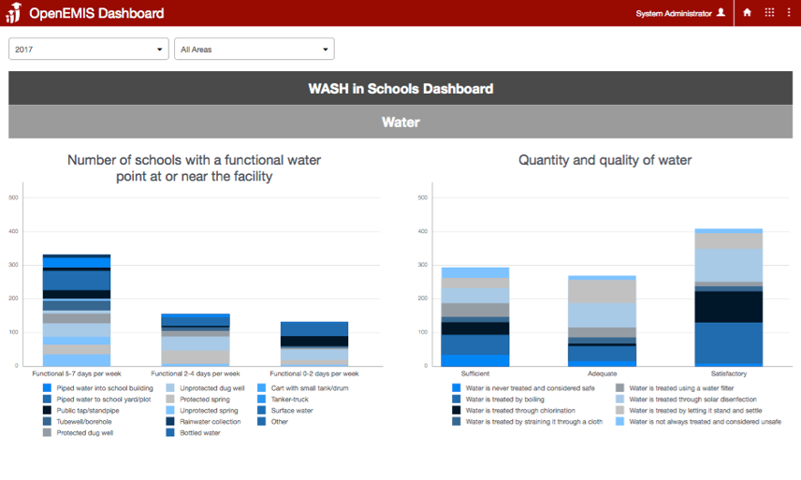

Measurement
Following list of indicators and more can be monitored through OpenEMIS:
- Number of schools with a functional water point at or near the facility
- Quantity and quality of water
- Percentage of schools with water points accessible to students with disabilities
- Number of functional toilets and urinals for girls, boys, and teachers that meet national standards
- Percentage of schools with toilets and urinals accessible to students with disabilities
- Number of schools with functional handwashing facilities and soap (or ash) available for girls and boys in the school
- Percentage of schools where hygiene is taught
- Number of schools where solid waste and sludge is regularly disposed
- Number of schools where sewage is emptied

Support
To ensure quality project activities for long-term sustainable development, OpenEMIS is providing six types of services (i.e. Policy and Planning Services; Analytical Services; Implementation Services; Support Services; Ad Hoc Services; and Software Development Services) along with Training Services (i.e. Professional; Administrator; Analyst; Trainer; and Advanced Lab) for countries’ capacity building. Moreover, OpenEMIS runs Service Desk from education experts and technicians to support users’ questions and requests as well as online OpenEMIS Support where clients get access to the knowledge base on all applications.

References
United Nations Educational, Scientific and Cultural Organization (UNESCO). Education Indicators Technical Guidelines 2009 (English, PDF).
https://www.openemis.org/files/resources/Indicator_Technical_guidelines_en.pdf

United Nations Children’s Fund (UNICEF). Advancing WASH in Schools Monitoring – Working Paper. https://www.unicef.org/wash/schools/files/Advancing_WASH_in_Schools_Monitoring(1).pdf

United Nations Children’s Fund (UNICEF). Water, Sanitation, and Hygiene (WASH) in Schools. https://www.unicef.org/publications/files/CFS_WASH_E_web.pdf

United Nations Children’s Fund (UNICEF). WASH in Schools Monitoring Package.
https://www.unicef.org/wash/schools/files/wash_in_schools_monitoringpackage_.pdf

https://www.openemis.org/support/

