OpenEMIS Concept Note – Monitoring Education Plans
Tracking and Monitoring Education Plans Data
using an Open Education Management Information System (OpenEMIS)

May, 2018



Title
Tracking and Monitoring Education Plans Data using an OpenEMIS

OpenEMIS Initiative
The OpenEMIS Initiative aims to deploy a high-quality Education Management Information System (EMIS) designed to collect and report data on schools, students, teachers, and staff. The system was conceived by UNESCO to be a royalty-free system that can be easily customized to meet the specific needs of member countries. The initiative is coordinated by UNESCO with technical support provided by Community Systems Foundation. OpenEMIS is well positioned to support national system strengthening in the country while addressing the monitoring requirements of Sustainable Development Goals. OpenEMIS is deployed as a cloud-based application and is designed to be mobile responsive, allowing for access to smartphones and tablets as well as more traditional laptop and desktop computers. A suite of tools is available to enhance OpenEMIS software, providing solutions for data collection, management, analysis and procurement of resources.

Issue
With the adoption of new Sustainable Development Goals (SDGs), the international community is acknowledging the urgency of facilitating financial investment mechanism in education sector more than ever. Responding to that, the Education Commission in collaboration with international organizations has introduced the initiative of “International Finance Facility for Education (IFFEd)” to mobilize over $13 billion annually for education by 2020. In a same sense, the Education Commission recommended national leaders to strengthen the performance of education systems by learning from results-driven systems across sectors and set standards, track progress, and make information public. A strong, credible Education Sector Plan (ESP) lays the foundation for mobilizing resources and aligning efforts to achieve SDGs. Hence, in order to have a reliable ESP, it cannot be emphasized enough the importance of use of data and to interpret and deploy to foster accountability.

Approach/Solution
OpenEMIS Monitoring is a web-based application to facilitate the Monitoring and Evaluation (M&E) of indicators against the Education Sector Plan (ESP). The ESPs present the policies and strategies for national education reform and are a powerful tool for coordinating partners and for mobilizing additional domestic and external resources. The online ESP monitoring system will increase accessibility to the results framework, link the framework to data for monitoring the plan, and assist education planners and the Ministry of Education in jointly coordinating these activities to achieve the desired results. The system measures deviations from planned activities, objectives, and goals, and can be used as a tool for both formative and summative evaluation. The system is expected to reduce transaction costs and improve the quality of data used to monitor the ESP.

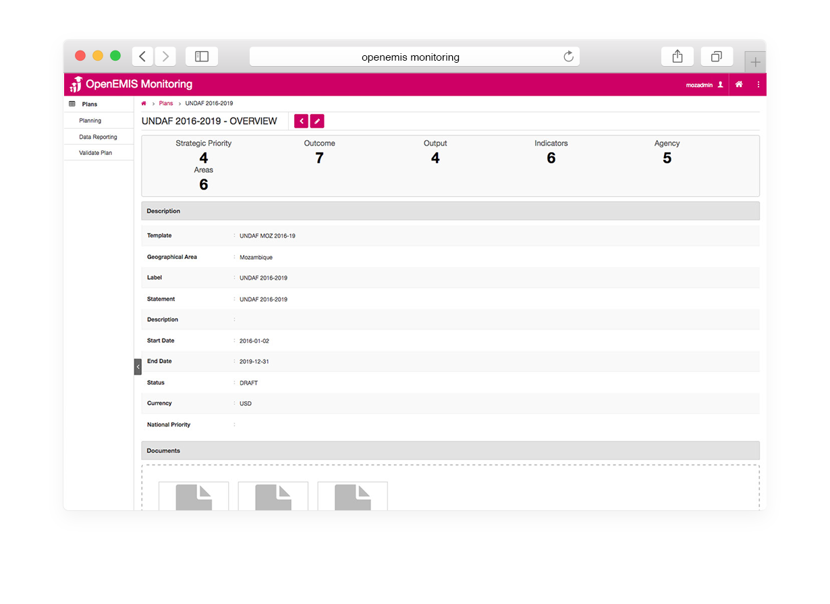

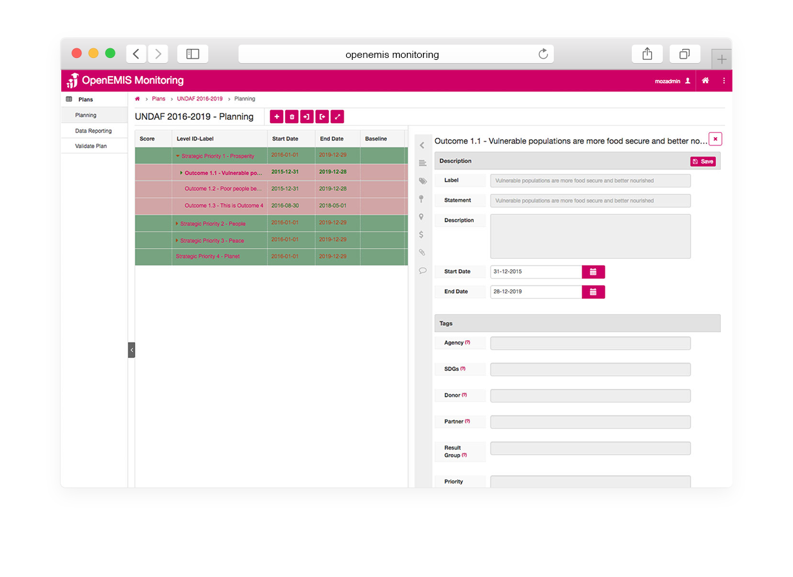

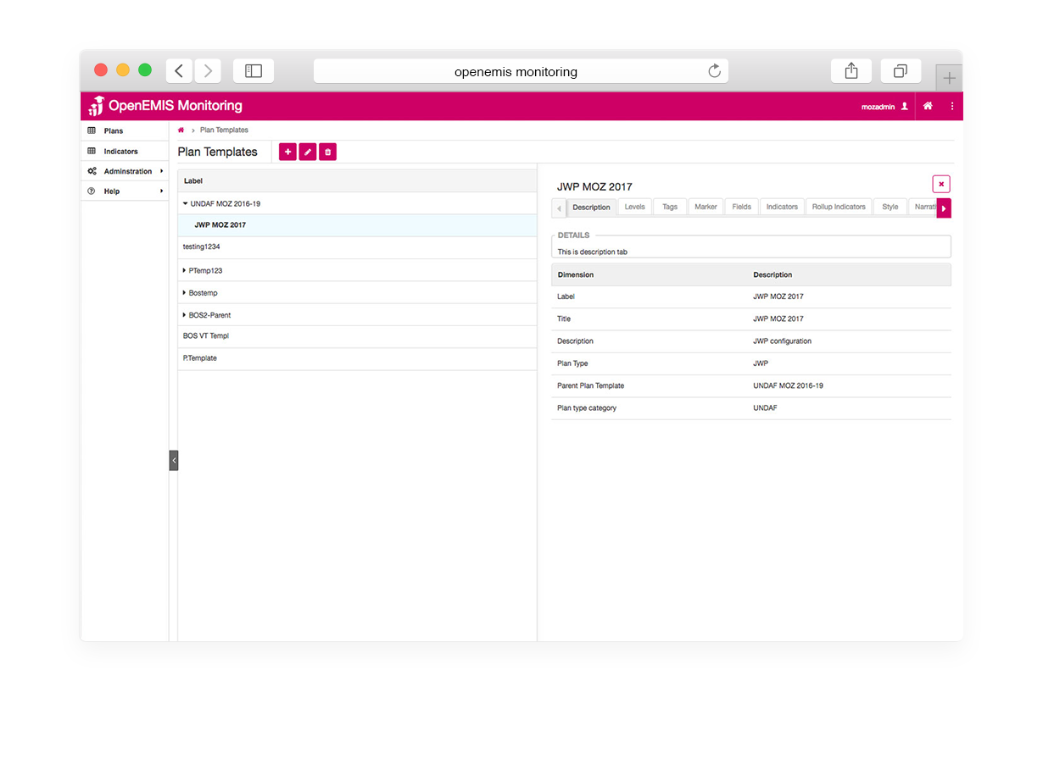

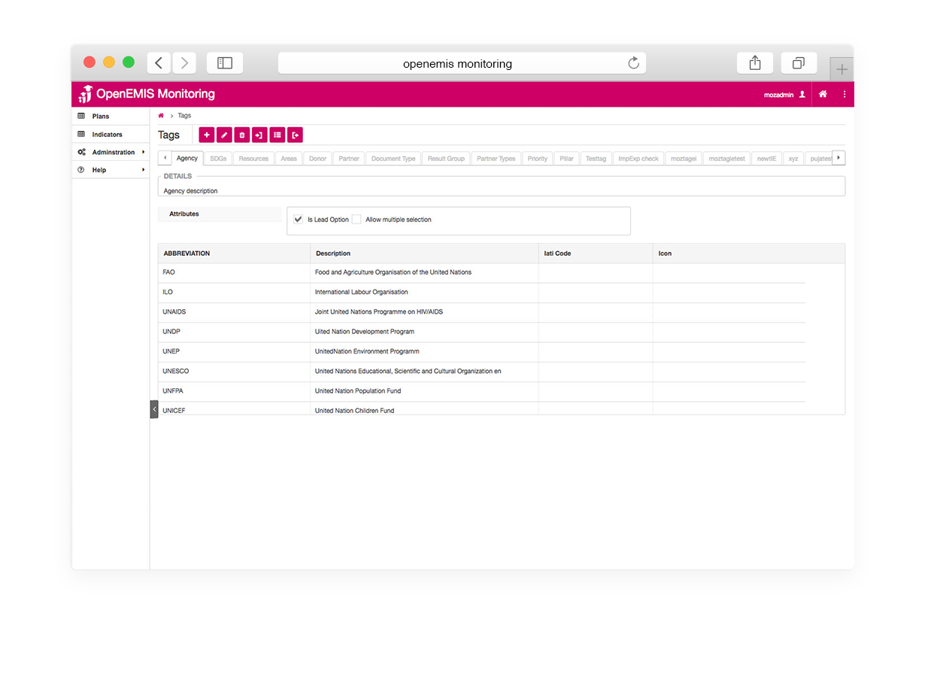

Measurement
Following list of indicators and more can be monitored through OpenEMIS:
- ESP indicators
- Number of students / staff / institutions (enrolment)
- Percentage of students identified as vulnerable (e.g. disability)
- Number of qualified teaching staff in institutions
- Number of students identified as risk of dropout
- Gross enrolment ratio; Net enrolment rate
- Pupil-teacher (educator-child) ratio
- Out of school children/adolescent rate
- Student absenteeism rate
- Percentage of students meeting a national standard in numeracy and literacy (learning assessment)

Support
To ensure quality project activities for long-term sustainable development, OpenEMIS is providing six types of services (i.e. Policy and Planning Services; Analytical Services; Implementation Services; Support Services; Ad Hoc Services; and Software Development Services) along with Training Services (i.e. Professional; Administrator; Analyst; Trainer; and Advanced Lab) for countries’ capacity building. Moreover, OpenEMIS runs Service Desk from education experts and technicians to support users’ questions and requests as well as online OpenEMIS Support where clients get access to the knowledge base on all applications.

References
The Education Commission. A Proposal to Create a New International Finance Facility for Education. http://educationcommission.org/wp-content/uploads/2017/03/IFFEd-Overview-4-17.pdf

The Education Commission. The Learning Generation – Investing in Education for a Changing World. http://report.educationcommission.org/wp-content/uploads/2016/09/Learning_Generation_Full_Report.pdf

United Nations Educational, Scientific and Cultural Organization (UNESCO). Education Indicators Technical Guidelines 2009 (English, PDF).
https://www.openemis.org/files/resources/Indicator_Technical_guidelines_en.pdf

United Nations Educational, Scientific and Cultural Organization – International Institution for Educational Planning (UNESCO-IIEP). Guidelines for Education Sector Plan Preparation 2015.
http://unesdoc.unesco.org/images/0023/002337/233767e.pdf

https://www.openemis.org/support/

