OpenEMIS Concept Note – ECDE
Tracking and Monitoring Early Childhood Development and Education Data using an Open Education Management Information System (OpenEMIS)

March 2026



Tracking and Monitoring Early Childhood Development and Education (ECDE) Data using an OpenEMIS

Executive Summary
This concept note proposes the deployment of OpenEMIS to enable governments to track, monitor, and improve early childhood development and education (ECDE) outcomes through integrated, child-level data systems aligned with Sustainable Development Goal (SDG) 4.2.

OpenEMIS provides a government-owned, open-source Education Management Information System (EMIS) that supports the collection, management, and use of high-quality data across the education sector, including early childhood. By establishing longitudinal learner records from early childhood onward, OpenEMIS enables evidence-based decision-making, improved service delivery, and better outcomes for children.

The Challenge
Early childhood, defined as the period from birth to eight years old, is a critical phase of rapid development across social, emotional, cognitive, and physical domains. Ensuring that children are developmentally on track is essential for lifelong learning and wellbeing.

Despite global commitments under SDG 4.2—“By 2030, ensure that all girls and boys have access to quality early childhood development, care and pre-primary education so that they are ready for primary education”—many countries face significant challenges in monitoring ECDE systems.

Key challenges include:
- Fragmented or non-existent data systems for early childhood
- Sometimes informal nature of ECDE centers present challenge to structured data collection
- Limited availability of developmentally on-track data
- Weak integration between education, health, nutrition, and social services
- Inadequate tools for tracking individual child development over time

These gaps constrain governments’ ability to:
- Design effective policies
- Target vulnerable populations, ensuring no young learner is left behind
- Allocate resources efficiently
- Monitor progress toward national and global goals

Why Now
Growing global investment in early childhood development, combined with advances in digital public infrastructure, presents a timely opportunity to establish integrated ECDE data systems at scale. Governments increasingly require real-time, reliable data to inform policy and improve service delivery, particularly in support of SDG 4.2.

OpenEMIS Initiative
The OpenEMIS Initiative aims to deploy a high-quality Education Management Information System designed to collect and report data on schools, students, teachers, and staff. The system was conceived by UNESCO as a royalty-free solution that can be customized to meet the specific needs of member countries.

Now in its 15th year, the initiative is coordinated by Community Systems Foundation (CSF). OpenEMIS is well positioned to support national system strengthening while addressing the monitoring requirements of the Sustainable Development Goals.

OpenEMIS is deployed as a web-based application and is mobile responsive, enabling access via smartphones, tablets, laptops, and desktop computers. A suite of tools enhances the platform’s capabilities in data collection, management, analysis, and resource planning.

Solution and Value Proposition
OpenEMIS offers a customizable, non-commercial platform that enables countries to strengthen ECDE systems through integrated, child-centered data.
Through OpenEMIS, governments can:
- Establish unique learner identifiers from early childhood
- Capture holistic child data, including demographic, health, nutrition, and developmental information
- Track longitudinal learning trajectories across education levels
- Generate real-time indicators aligned with national priorities and SDG 4.2
- Support evidence-based decision-making at all levels

OpenEMIS uniquely enables countries to build sustainable, government-owned systems without vendor lock-in, while supporting interoperability with other national systems.

Approach
The implementation of OpenEMIS for ECDE follows a results-oriented approach:
Inputs
- OpenEMIS platform and tools
- National customization and configuration
- Capacity building and training
System Functionality
- Individual learner records with unique IDs
- Data capture on enrollment, attendance, development, and context
- Dashboards, reports, and data portals
Outputs
- Real-time ECDE data and indicators
- Integrated datasets across institutions and learners
Outcomes
- Improved identification of children needing support
- Better planning and resource allocation
- Enhanced coordination across sectors
Impact
- Increased proportion of children entering primary school developmentally on track

System Functionality
OpenEMIS Core provides a robust solution to collect, manage, and use ECDE data.

At the individual level, each child enrolled in an ECDE program is assigned a unique ID, enabling the creation of comprehensive learner records. These records may include:
- Demographic background
- Health and nutrition data
- Participation and attendance patterns
- Behavioral observations
- Early learning and developmental milestones (e.g., fine motor skills)

These records support:
- Teachers in adapting learning activities and identifying children needing additional support
- Schools in planning resources, staffing, and inclusive strategies
- Ministries in analyzing trends and planning interventions

Importantly, learner records follow children as they transition from early childhood into primary and secondary education, creating a continuous education profile. Records can be integrated with other government systems such as health and social services.

OpenEMIS also supports the generation of transactional reports and dashboards, enabling the transformation of raw data into actionable insights through data portals and visualization tools.

Figure 1 - Student list  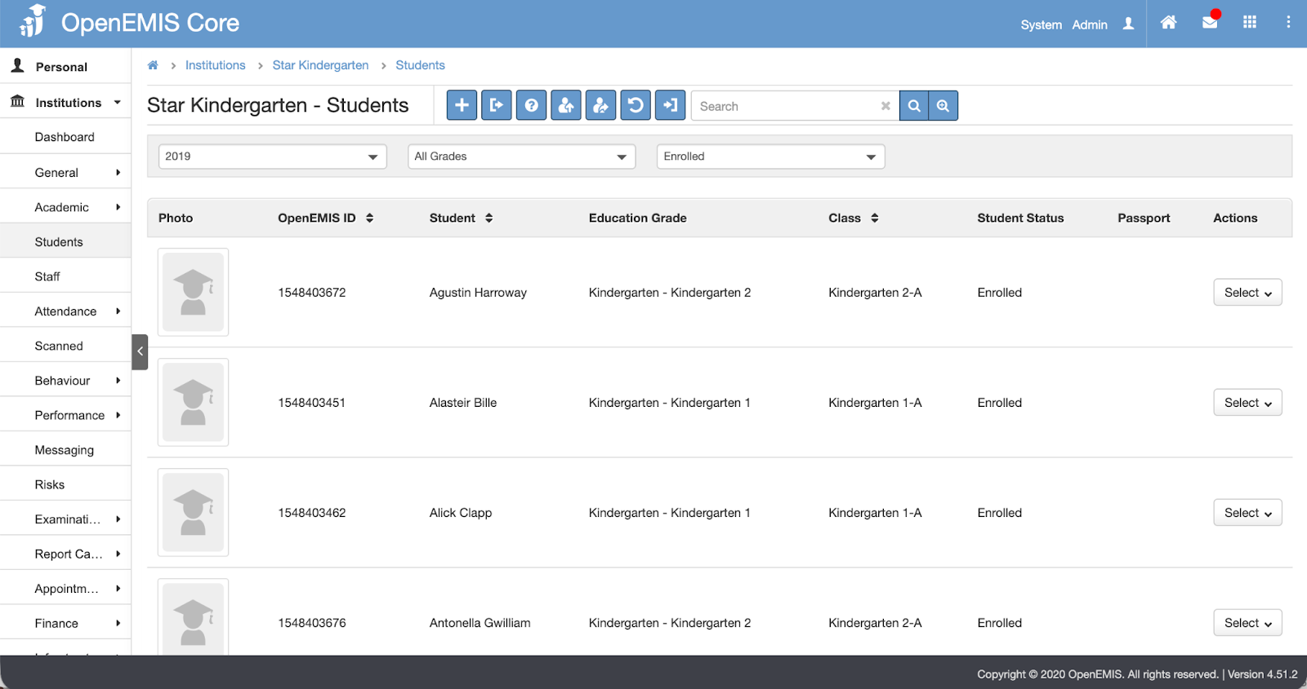 | Figure 2 - Student Record  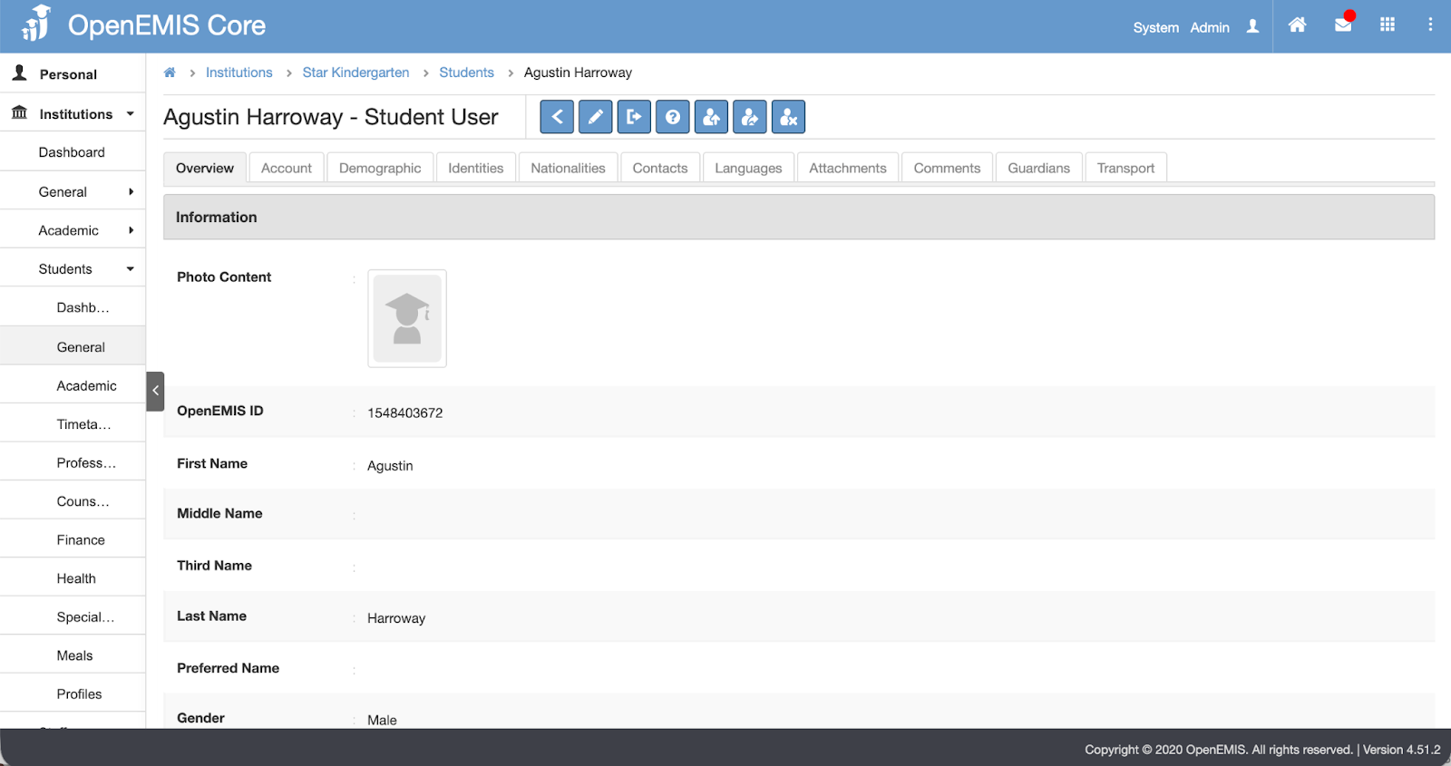
Figure 3 - Student Academic History  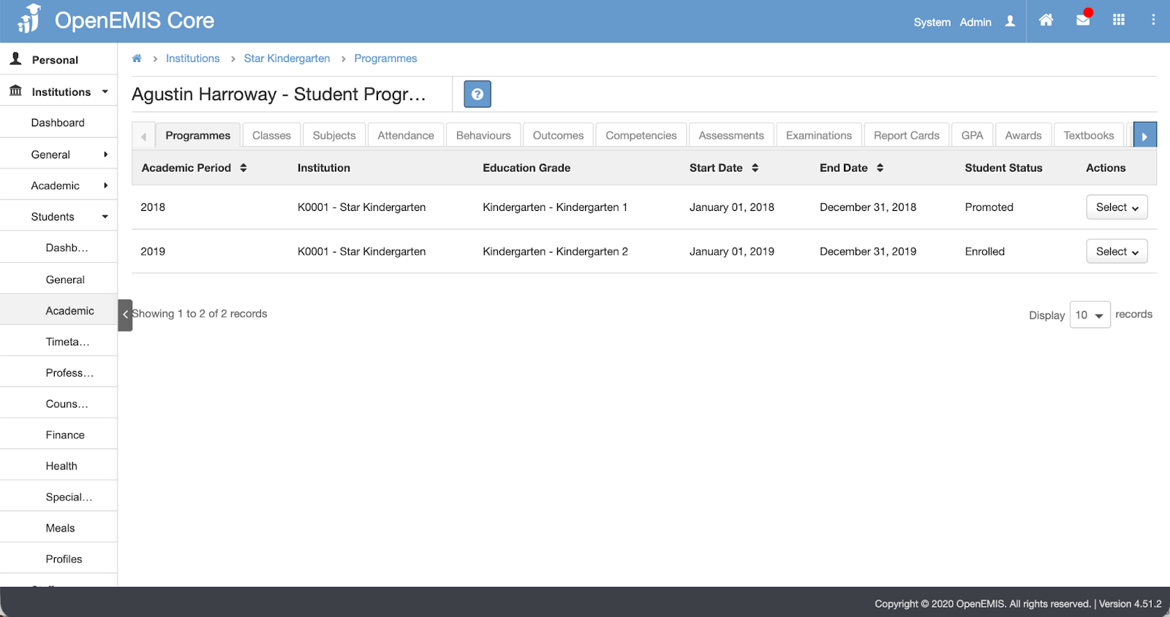 | Figure 4 - Student Health Record  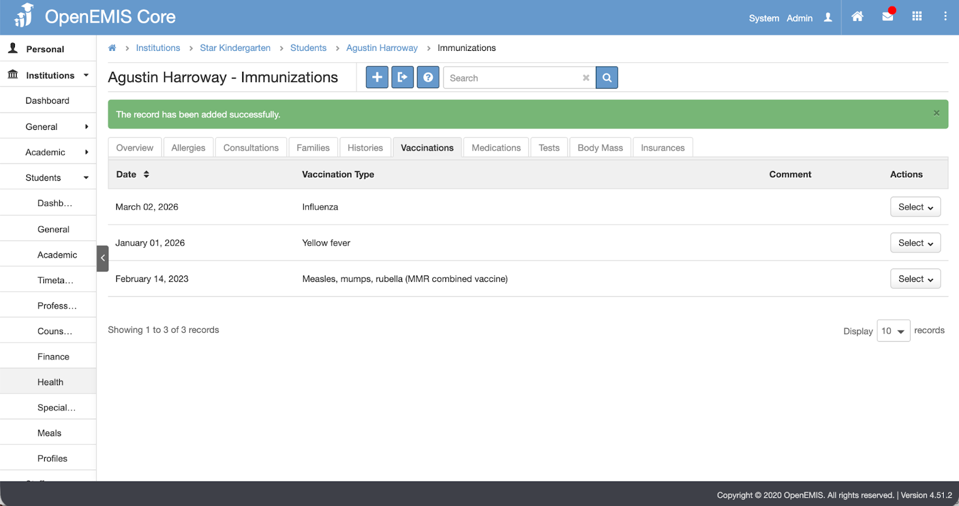
Figure 5 - Student Special Needs  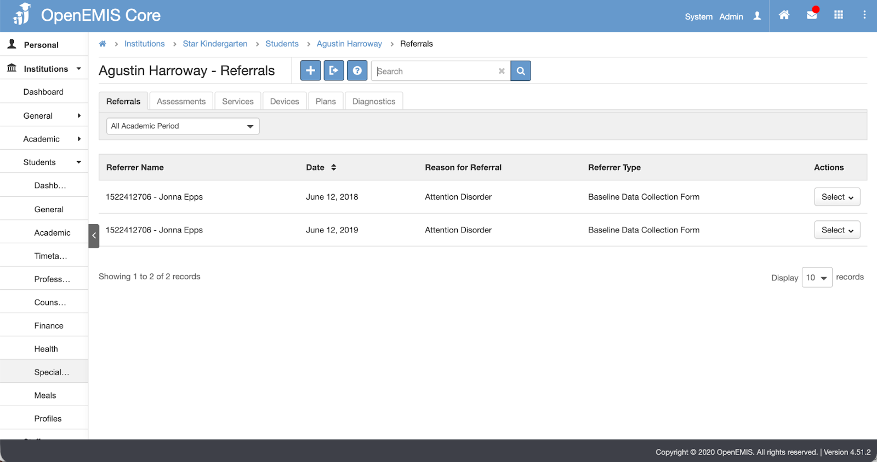 | Figure 6 - Sample Report  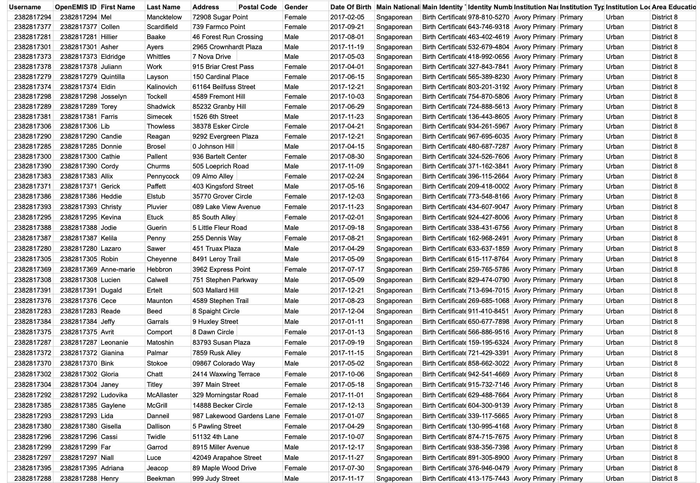
Figure 7 - Sample Data Portal  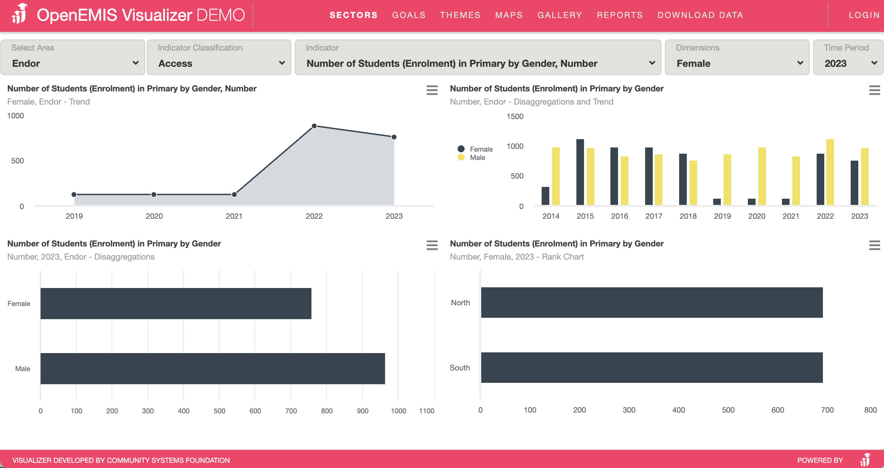 | Figure 8 - Sample Dashboard  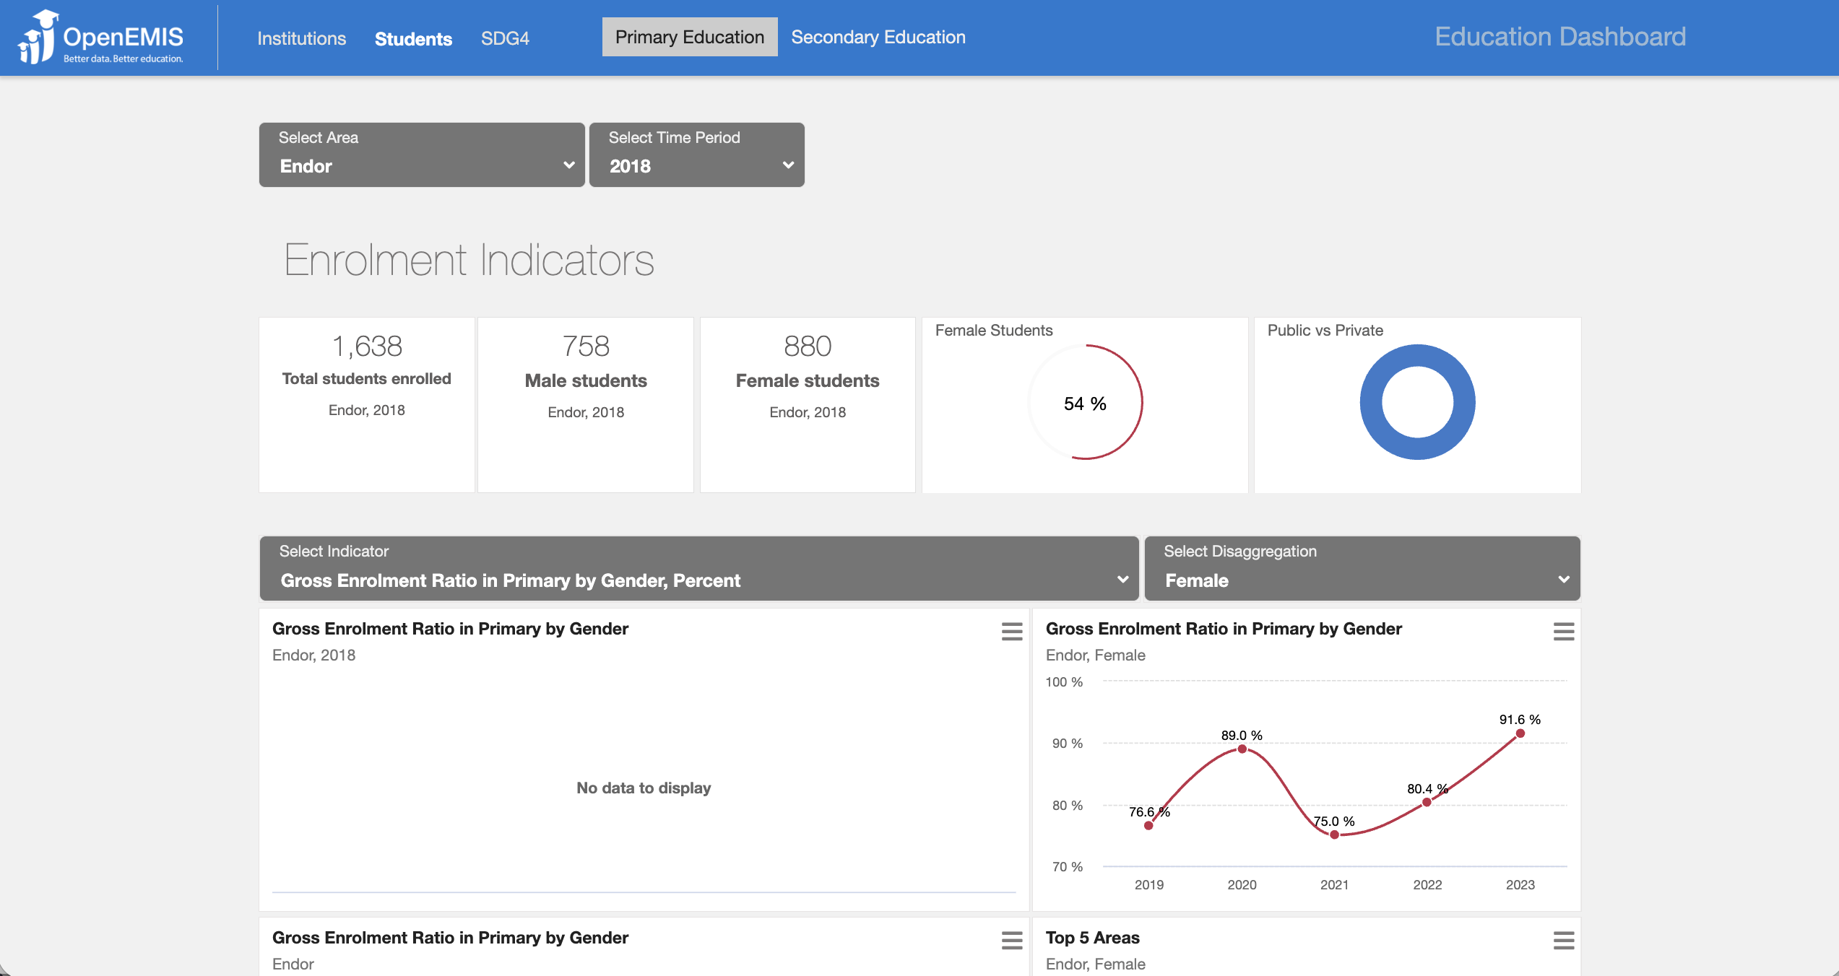

Use Cases
Teacher Level
- Identify children with developmental delays
- Adapt teaching approaches to individual needs
School Level
- Plan staffing and classroom resources
- Monitor attendance and participation patterns
District Level
- Target underserved or vulnerable populations
- Allocate resources based on real-time data
National Level
- Inform ECDE policy and planning
- Monitor progress toward SDG 4.2
- Coordinate interventions across sectors

Measurement Framework
OpenEMIS supports the collection and production of internationally aligned ECDE indicators, including:
Access and Participation
- Number of students in pre-primary institutions
- Gross enrolment ratio in pre-primary
- Participation rate in organized learning
Equity
- Percentage of students identified as vulnerable (e.g., disability)
System Capacity
- Number of pre-primary institutions
- Number of staff and qualified teaching staff
Transition and Outcomes
- Percentage of children aged 6–7 entering school who attended preschool

These indicators can be produced in near real time and disseminated through dashboards, reports, and interactive data portals to support decision-making at all levels.

Implementation and Support
To ensure sustainable implementation, OpenEMIS provides a comprehensive package of services, including:
- Policy and Planning Services
- Analytical Services
- Implementation Services
- Support Services
- Software Development Services
- Ad Hoc Services

In addition, the OpenEMIS Lab offers structured training programs (to build national capacity.

A dedicated Service Desk, supported by education experts and technicians, provides ongoing user support, complemented by an online knowledge base available through OpenEMIS Support.

Community Systems Foundation (CSF) provides technical support across all phases of implementation, emphasizing country ownership, capacity development, and long-term sustainability.

References
United Nations Educational, Scientific and Cultural Organization (UNESCO). Early Childhood Care and Education. https://en.unesco.org/themes/early-childhood-care-and-education

United Nations Children’s Fund (UNICEF). Early Childhood Development. https://www.unicef.org/earlychildhood/

United Nations Educational, Scientific and Cultural Organization (UNESCO). Education Indicators Technical Guidelines 2009 (English, PDF).
https://www.openemis.org/files/resources/Indicator_Technical_guidelines_en.pdf

OpenEMIS features hundreds of transactional data reports, including reports on institutions, students and all elements of data collected through the system. Here are some examples:
- Institutions_ Institutions - All Areas Level - All Areas - All Institutions - 20260312T151144.xlsx
- Students_ Students - 2026 - -- Select -- - -- Select -- - P1002 - Avory Primary School - March 12, 2026 to March 12, 2026 - 20260312T151914.xlsx

OpenEMIS software can transform raw data into indicators, to automate the production of sub-sector Key Performance Indicators. These indicators can be disseminated through reports, data portals and dashboards. Here are some examples:
- Schools’ dashboard (example, but without ECE schools included)
- Students’ dashboard (example, but without ECE schools included)
- WASH in Schools
- Textbooks (example: could be any essential ECE equipment)
- Interactive Data Portal

