OpenEMIS Concept Note – OpenEMIS as Education Digital Public Infrastructure
Building Education Digital Public Infrastructure for the Next Generation of National Education Systems

June 2026 – DRAFT for comment



OpenEMIS Concept Note – OpenEMIS as Education Digital Public Infrastructure
Building Education Digital Public Infrastructure for the Next Generation of National Education Systems

Executive Summary
Governments worldwide are increasingly investing in Digital Public Infrastructure (DPI) as the foundation for modern public service delivery. While initial DPI investments focused on digital identity, payments, and data exchange, attention is rapidly expanding toward sectoral Digital Public Infrastructure that supports education, health, social protection, and other public services.
Education systems require trusted, interoperable, and sustainable digital foundations capable of supporting policy planning, service delivery, learning systems, teacher management, assessment platforms, and evidence-based decision making.
OpenEMIS was designed to meet these requirements.
As a Digital Public Good deployed across more than 30 countries, OpenEMIS provides a modular, open-source, interoperable platform that enables governments to collect, manage, exchange, analyze, and use education data across the entire education ecosystem.
Rather than functioning solely as an Education Management Information System (EMIS), OpenEMIS can serve as the Education Data and Registry Layer within national Digital Public Infrastructure ecosystems.
OpenEMIS can serve as, or integrate with, authoritative education registries while providing the interoperability, analytics, and data services required to support modern education systems.
This paper outlines how OpenEMIS aligns with Digital Public Infrastructure principles and presents a vision for OpenEMIS as foundational Education Digital Public Infrastructure (Education DPI).

Why Education Systems Need Digital Public Infrastructure
There is growing global interest in applying Digital Public Infrastructure approaches to education as governments seek to build more integrated, sustainable, and data-driven public service systems.
Education systems often depend on multiple digital platforms for administration, learning, assessment, teacher management, financing, and reporting. When these systems operate independently, they can create fragmented data, duplicated records, inconsistent reporting, and limited capacity to use information across the sector.
Digital Public Infrastructure for education provides a way to address this fragmentation by establishing shared digital foundations for the sector. These foundations include trusted education registries, interoperable data services, open APIs, and reusable analytics capabilities that can support multiple applications and services.
Education DPI is critical because it enables governments to move from isolated education technology projects toward connected national ecosystems. By allowing education systems to securely exchange data, reuse common infrastructure, and generate trusted information for decision-making, Education DPI strengthens governance, improves service delivery, and supports more equitable and effective education outcomes.

The Evolution from EMIS to Education DPI
Historically, education technology investments focused on individual applications:
- Education Management Information Systems
- Student Information Systems
- Teacher Management Systems
- Assessment Systems
- Learning Management Systems
- School Census Systems

These systems were implemented, creating fragmented data environments and limiting interoperability.
Digital Public Infrastructure introduces a different paradigm.
Instead of building isolated applications, governments establish shared digital foundations that support multiple services and applications.
Within this model:
- Data becomes a shared national asset.
- Registries become foundational infrastructure.
- APIs enable interoperability.
- Analytics become reusable services.
- Applications become consumers and producers of shared data.

This evolution creates the concept of Education Digital Public Infrastructure.

What is Education Digital Public Infrastructure?
Education DPI consists of foundational digital assets that support the education sector as a whole. These assets may include:

Education Registries  - School registries  - Student registries  - Staff registries  - Guardian registries | Analytics Services  - Dashboards  - Indicators  - Monitoring systems  - Planning tools
Shared Data Services  - Data exchange services  - Interoperability frameworks  - API gateways  - Metadata services | Sector Applications  - EMIS  - LMS  - Assessment systems  - School finance systems  - Teacher professional development platforms

Education DPI enables these systems to operate as part of a connected ecosystem rather than as standalone applications.

OpenEMIS as a Digital Public Good
Digital Public Infrastructure is most effective when it is built upon open, reusable, and sustainable digital foundations. This principle has contributed to the growing importance of Digital Public Goods (DPGs) as building blocks for national digital transformation.
A Digital Public Good is open-source software, data, content, AI model, or standard that adheres to privacy and other applicable best practices, contributes to sustainable development, and is designed to promote equitable access to public services and opportunities.
OpenEMIS embodies these principles.
As an open-source platform developed for and with governments, OpenEMIS enables countries to strengthen education systems while maintaining ownership of their data, infrastructure, and digital transformation strategies. OpenEMIS is designed to be adaptable to diverse national contexts, reducing dependence on proprietary solutions and helping governments avoid vendor lock-in.
The open architecture of OpenEMIS promotes transparency, interoperability, and long-term sustainability. Governments and development partners can deploy, extend, integrate, and enhance OpenEMIS while benefiting from investments made across a global community of users and contributors.
The relationship between Digital Public Goods and Digital Public Infrastructure is mutually reinforcing. While Digital Public Goods provide reusable digital building blocks, Digital Public Infrastructure provides the institutional and technical frameworks through which those building blocks deliver public value at scale.
OpenEMIS combines both concepts.
As a Digital Public Good, OpenEMIS provides countries with an open, reusable, and adaptable platform. As Education Digital Public Infrastructure, OpenEMIS provides the foundational education registries, data services, interoperability mechanisms, and analytics capabilities required to support education sector governance, service delivery, and evidence-based decision making.
This combination enables countries to establish sustainable and nationally owned education ecosystems while benefiting from a shared global public good that continues to evolve through international collaboration and innovation.

OpenEMIS Vision
OpenEMIS is designed as a modular ecosystem of interoperable applications that support the full education data lifecycle:
Collect → Manage → Analyze → Act
The OpenEMIS architecture provides:
- Data collection services including mobile apps
- Data management services including integration and data warehousing
- Data Analytics including monitoring and visualization

Together these loosely coupled components create a foundation for national Education Digital Public Infrastructure.

OpenEMIS as an Education Registry Platform
Trusted registries are a foundational component of Digital Public Infrastructure. OpenEMIS can serve as, or integrate with, authoritative education registries. Depending on national policy and architecture decisions, OpenEMIS may support:
School Registry
Providing authoritative information on schools, institutions, facilities, and education providers.
Student Registry
Maintaining learner records, enrollment history, progression, attendance, and related educational information.
Staff Registry
Managing teacher identities, assignments, qualifications, professional development, and workforce planning data.
Education Structure Registry
Maintaining information about districts, regions, ministries, and administrative structures.

These registries create trusted education data assets that can be consumed by multiple systems and services across government.

OpenEMIS Modular Architecture
A defining characteristic of Digital Public Infrastructure is modularity.
OpenEMIS was designed as a suite of interoperable applications that can be deployed independently or as an integrated national platform.
Data Collection Layer
OpenEMIS Classroom
Supports classroom-level education data collection and management.
OpenEMIS Staffroom
Supports teacher and staff-related workflows and information management.
OpenEMIS Survey
Supports surveys, questionnaires, and targeted data collection initiatives.
OpenEMIS Scanner
Scanning barcodes and QR codes for identification and tracking.
OpenEMIS Admissions
Supports student registration and enrollment processes.
Data Collection / Management System Layer
OpenEMIS Core
Provides foundational education management functionality.
OpenEMIS School
Supports school-level administration and operational management.
OpenEMIS Guardian
Facilitates engagement with parents and guardians.
OpenEMIS Exams
Supports examination and assessment administration.
Data Management Layer
OpenEMIS DataManager
Data management and administration services.
OpenEMIS Data Warehouse
The Data Warehouse provides a centralized repository for education information originating from OpenEMIS applications and external systems.
This layer supports:
- Longitudinal analysis
- Statistical reporting
- National indicators
- Evidence-based planning
- Cross-sector analytics
OpenEMIS Integrator
OpenEMIS Integrator serves as the data pipeline of the OpenEMIS ecosystem.
It enables:
- External data ingestion
- Data aggregation
- Data synchronization
The Integrator allows OpenEMIS to participate in broader national digital ecosystems while maintaining data consistency and governance.
Analytics and Decision Support Layer
OpenEMIS Dashboard
Real-time education monitoring and reporting.
OpenEMIS Visualizer
Advanced data visualization and exploration.
OpenEMIS Monitoring
Results monitoring and performance tracking.
OpenEMIS Charts
Mobile access to education analytics.
OpenEMIS Chatbot
Conversational access to education information and analytics.

API-First Architecture and Interoperability
Interoperability is a defining characteristic of Digital Public Infrastructure.

OpenEMIS adopts an API-first approach that enables education data and services to be securely shared across systems.

OpenEMIS API Portal

The OpenEMIS API Portal provides documented interfaces that allow developers, governments, and partner systems to interact with OpenEMIS services.

The API framework supports transparent and standardized integration approaches while promoting long-term sustainability and reuse.

REST-Based Services

OpenEMIS exposes services through RESTful APIs that support secure access to education data and functionality.

These APIs enable authorized systems to retrieve, update, and exchange information in a standards-based manner.

Machine-to-Machine Integration

OpenEMIS supports machine-to-machine integration between:
- National digital identity systems
- Civil registration systems
- Learning management systems
- Assessment platforms
- Human resource systems
- Financial management systems
- Social protection systems
- Government interoperability platforms
- National statistical systems

This capability allows OpenEMIS to function as a participant within national digital ecosystems rather than as an isolated application.

Data Exchange Services

Through APIs and integration services, OpenEMIS enables:
- Real-time data exchange
- Event-driven workflows
- Automated synchronization
- Cross-sector reporting
- Shared service delivery

This interoperability foundation is essential for Education Digital Public Infrastructure.

OpenEMIS within National DPI Ecosystems
OpenEMIS is designed to integrate with broader government Digital Public Infrastructure.
A typical national architecture may include:
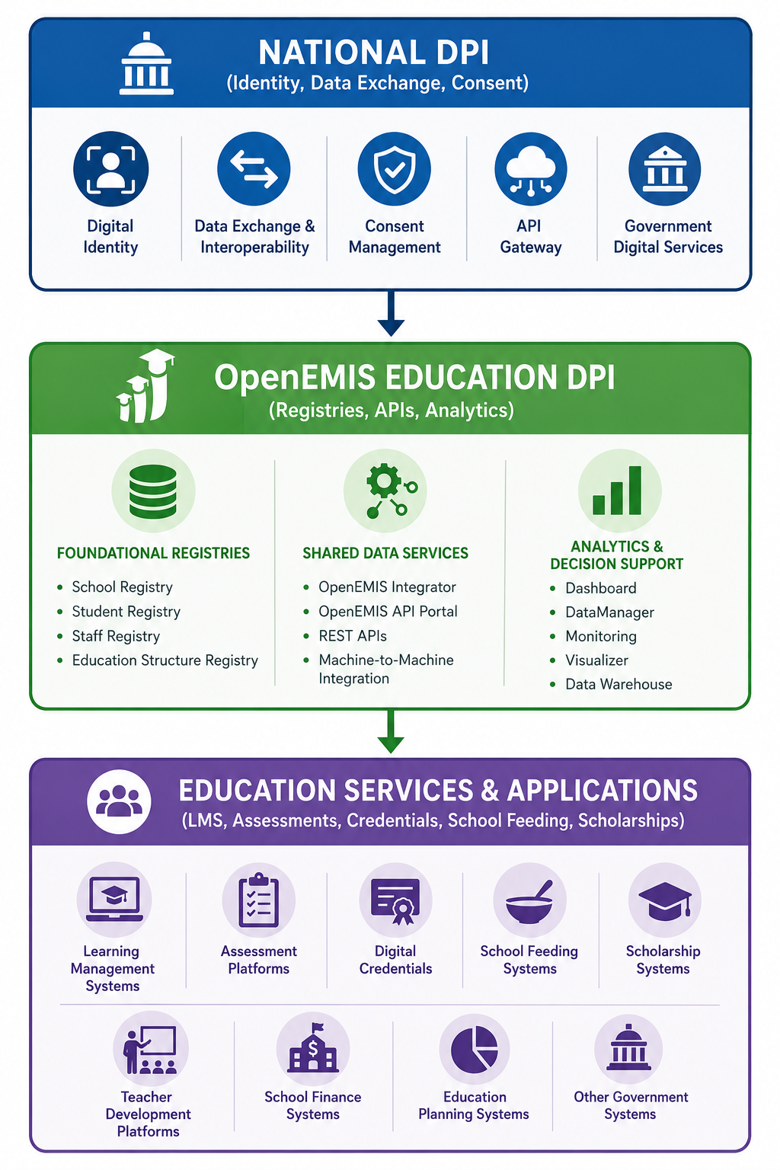
National DPI Layer
- Digital Identity
- Interoperability Framework
- API Gateway
- Data Exchange Platform
- Consent Management Services
- Digital Payments

Education DPI Layer
OpenEMIS provides:
- Education registries
- Education data services
- Education analytics
- Education interoperability services

Sector Applications
Connected applications may include:
- Learning management systems
- Examination platforms
- Scholarship systems
- School grants systems
- Teacher development systems
- Digital credential systems
- Workforce planning systems

In this model OpenEMIS functions as the education data backbone supporting multiple services and applications.

Alignment with GovStack
GovStack is a global initiative that promotes reusable Digital Public Infrastructure building blocks for governments.
The GovStack framework defines common building blocks that can be assembled into interoperable government ecosystems.
OpenEMIS aligns strongly with the GovStack vision through its emphasis on:
- Modularity
- Open standards
- Interoperability
- Reusable services
- Public ownership
Future OpenEMIS development will include formal mapping of OpenEMIS capabilities against relevant GovStack building blocks.
Potential areas of alignment include:
- Registry Building Blocks
- Information Mediation Building Blocks
- Consent Management Services
- Digital Identity Integration
- Data Exchange Services
- Analytics and Decision Support Services
This mapping will help governments position OpenEMIS within broader national digital transformation strategies.

Strategic Roadmap for Education DPI
The evolution of OpenEMIS as Education Digital Public Infrastructure will focus on five strategic pillars.

Education Registries - Strengthening trusted registry services for schools, teachers, students, and institutions.

Interoperability - Expanding standards-based API services and integration capabilities.

National DPI Integration - Deepening integration with digital identity, interoperability, and data exchange platforms.

Advanced Analytics - Expanding decision-support, planning, forecasting, and AI-enabled services.

Digital Credentials and Learning Records - Supporting emerging national approaches to learner records, certifications, and lifelong learning pathways.

Conclusion
The future of education technology lies not in isolated applications but in interoperable digital ecosystems built upon trusted public infrastructure.
OpenEMIS represents a practical implementation of Education Digital Public Infrastructure.
OpenEMIS was designed around principles that are increasingly recognized as essential characteristics of Digital Public Infrastructure: openness, modularity, interoperability, scalability, and country ownership.
By providing foundational registries, interoperable data services, analytics capabilities, and open APIs, OpenEMIS enables governments to build integrated education ecosystems rather than isolated applications.
As countries pursue national digital transformation agendas, OpenEMIS offers a proven pathway for establishing the education data and registry layer of Digital Public Infrastructure—supporting better governance, better data, and better education outcomes.

https://www.openemis.org/
https://api.openemis.org/portal/

